# ROBOT FRAMEWORK

Catalog

ROBOT FRAMEWORK 1

1. Why Testing is important? 3

2. What is automation testing? 3

2.1 Advantages of automation testing 3

2.2 What is selenium 3

2.3 Advantages of selenium 3

3. Getting started 4

3.1 Introduction 4

3.2 Robot Framework 4

3.3 How Working Testing? 4

3.4 Why Robot Framework. 8

3.5 Why Robot Framework is High Level Architecture. 8

4. Installation and configuration. 17

4.1 Installation Commands 18

5. Write the First Test 22

6. Test data syntax 25

6.1 Test data Section 25

**Using Library setting** 25

7. Settings 28

7.1 Intro 28

1) Using Test Libraries 28

8. Variables 40

8.1 Variables write ways 41

**8.1.2 List** 42

**8.1.3 Dictionary** 43

8.2 Creating Variable or Custom variable 45

1. Number variable (Evaluate) 46

2) output Directory 48

9. Test Case Section 50

10. Keywords section 51

10.1 Types of Keywords 54

10.1.1 Build-in keywords 54

**10.1.2 User-defined (Custom) Keywords** 60

11. Locators (Path) 62

12. Commonly used in selenium Keywords 63

12.1 Browser Control 63

12.2 Element Locator in SeleiumLibarry 70

12.3 Page Interaction Keywords in selenium 79

Task1 85

12.4 **Waits & Timings in Robot Framework** 94

12.5 Box 95

12.6 Alert Boxes 103

13. Selenium Keyword vs Custom Keyword 105

13.1 Selenium Keyword 105

13.2 Custom Keywords 105

14. Normal Part of the Robot Framework settings. 106

15. Testing 110

**15.1 Acceptance Testing** 110

14.2 Keyword-Driven Testing (KDT) 112

14.3 Data –Driven Testing (DDT) 117

14.4 Behaviour Driven Testing(BDT) 117

14.5 Robotic Process Automation(RPA) 117

15. Advance Topic 118

15.1 How to add any id, class. 118

16. File Handling 122

17 CSV in Robot Framework 129

18 Control Statement 132

1. For 132

2. If Condition 136

19 Logging 139

19.1 String Handling 142

19.2 Data/Time 147

19.3 Sikuli 149

All Keywords 151

# 1. Why Testing is important?

Every application is developed for business purpose.

If there are any defects or bugs founded by end-user (or) public it will be spread negative impact across the market.

To avoid this things testing is very important.

Two Types of Testing

1. Manual Testing

2. Automation Testing

1. Manual Testing.

Testing the functionality of an application without using tools is called Manual Testing.

# 2. What is automation testing?

Testing the application with the help of some tool is called automation testing.

# 2.1 Advantages of automation testing

* It is a time saving process
* Less documentation is required

# 2.2 What is selenium

It is a web automation tool which is used to automated web application.

# 2.3 Advantages of selenium

* It support free and open source tool (Nmap, apache)
* It support 14+ languages(java, python, c, JavaScript)
* It support major browser (Chrome , Firefox , edge , safari)
* It support major operating support (windows, macos , Linux)

# 

# 3. Getting started

# 3.1 Introduction

Robot framework is a Python based automation framework. Work with Acceptance testing, Acceptance testing – driven Development (ATDD), Behavior driven development (BDD) and robotic process automation (RPA). It can be used in distributed, heterogeneous environments, where automation requires using different technologies and interfaces.

It is an open source automation framework for test automation.

# 3.2 Robot Framework

Developed by Pekka Klarck in 2005.

It is used for web testing, API testing, database testing.

Type – Software testing framework / test tool

It support windows and Linux.

It is supported by the Robot Framework Foundation and widely used in industry.

* Robot Framework Foundation - It is a non-profit (not investment to make profit (Business)) the growth of Robot Framework. It is developed by common interest to now and future.
* Widely used --- company like alpha, cisco, KONE, Nokia etc.

The framework has a rich ecosystem around in various generic libraries and tools that are developed as separate projects.

Robot Framework has an easy syntax, utilizing human readable keywords.

Robot Framework capabilities can be extended by libraries with python, java or many other programming languages.

It supports the keyword-driven, behavior -driven and data driven style of writing test cases.

[http://robotframework.org](http://robotframework.org/).

# 3.3 How Working Testing?

**1. Automation work for acceptance testing**

* + Acceptance testing means application work with end user before release.

**2. Acceptance testing – driven Development (ATDD)**

* + Before Acceptance testing the product meet user requirement.
  + Scenario - A user want to log in a web application
    - A user is on the login page
    - User enter valid username and password
    - Redirected to the home page
    - Welcome message display on username.
  + ATDD Process
    - It collaborate with developer, testing and business Analysts.
  + Benefit
    - Early Feedback
    - Clear Requirement (shared with team)
    - Risk reduce (Before release check with end user).
    - TDD follow agile methodologies

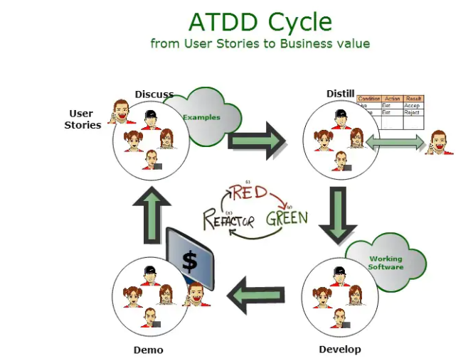 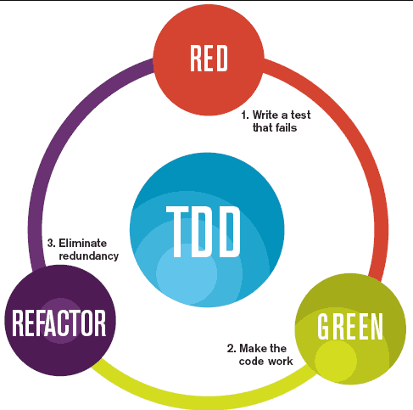

ATDD cycle

* User stories or discuss
  + During the planning meeting – common to virtually all methodologies / framework under the agile umbrella – tester and developers will discuss the task / user stories picked for implementation or sprint (task complete duration for example 1-4 weeks) with product owner / client.
* Distill
  + Distill refers to the stage where the team translates the user requirements and acceptance criteria into a format suitable for automation testing, machine readable (for example high level language (read and write for human and machine) if, else, try, else).
* Develop
  + Developer write the require application code
  + Implement the features, according to the specification.
  + Testing team also will work on application code
* Demo
  + After develop implement the features, they demo it to stakeholders.
    - Stakeholder (individual or group)
      * Works with organization like
      * Employees
      * Management
      * Shareholders
      * Customers
      * Suppliers

TDD (Test-Driven development)

Why use TDD:

Software Development approaches writing the code, leading to higher quality, more maintainable.

Benefits of Test-Driven Development (TDD).

1. Improved Code Quality
2. Early Bug Detection
   1. Writing tests before code allow for early detection and easier to fix than debugging issues later in the development cycle.
3. Reduced Debugging Time
   1. With TDD, spend less time debugging because they catch errors early on in the development process.
4. Long- Term Cost Savings:
   1. The long- term benefits of TDD, such as reduced debugging time, easier maintenance, and faster development cycles, and lead to significant cost savings.

* Red : Write a Failing Test
  + Your application doesn’t work as user expected.(user requirement)
  + For Example implementing open ‘Instagram app’, the first test to verify show the logo in front page or not.
* Green : Implement code to Pass the Test
  + Write the minimum amount of code necessary to make the failing test to pass.
  + After the test fails, write the code to fetch and return the Instagram logo.
* Refactor : Improve the Code
  + Purpose
    - Improve the code’s design , structure , and maintainability while ensuring all tests still pass
  + Maintainability
    - Code easy to understand and maintain, reducing the run time and required for future modification and bug fixes.

**3. Behavior driven development (BDD)**

Behavior – Driven Development (BDD) testing is a software development methodology and it is a part of agile method (Planning, design, coding, testing, deploy, and maintenance) that collaboration between developers, testers and business stakeholders to software meets outcomes and behaviors.

What is BDD TESTING?

User Login

Scenario: Successful login with valid data.

Given the user is on the login page

User enter valid data

Click the login button

User should be redirected to the dashboard

And see a welcome message.

BDD testing is the process of automation and executing these BDD scenarios.

Normal scenarios for manual Testing

Pen

Verify the pen write work or not

Verify the pen ink full or not

Verify the pen check any damage

..

In BDD testing is the process of automating and execute these BDD scenarios.**What is the Gherkin language?**

BDD scenarios for pen in robot framework ----- Write code in robot Framework

**4. Robotic Process Automation (RPA).**

Robotic process automation (RPA) is a software technology that makes it easy to build, deploy, and manage the software.

RPA involves using software “robots” to automate repetitive, rule-based tasks that humans typically performs.

* Automate repetitive -- tasks approach like loops (list of data), reusable keywords (test cases and automation scripts) and libraries to process and improve efficiency (separate module and maintain the large projects).
* Rule-based task
  + - * + ***Settings***
        + ***keywords***
        + ***variables***
        + ***Test Cases***

# 3.4 Why Robot Framework.

* It is an Open Source
* Created by python
* No Programming experience needed!
* Test Automation
* Keyword Based
* High level Architecture

# 3.5 Why Robot Framework is High Level Architecture.

Test suite (.robot)

|

Test Runner (robot)

|

Test Libraries [e.g. SeleniumLibrary, API, and Database]

|

Python Library or Tools

|

System under Test

**1. Clear Understand of System Components**

* The application under test like (web, API, Desktop etc.)
* External Tool (Selenium, Database)
* Test data sources and Reporting.
  + Test data
    - Internal test data
      * .robot or .resources
    - External Data files
      * Excel/csv using Data Driven
      * Json /operating System
      * Xml
      * Python Scripts
    - Environment Variable
      * Build In or Operating System
    - Database
      * Fetch data from database like sql
  + Reporting Mechanisms.
    - Build In Reports
      * Log.html
        + Details step-by-step execution log
      * Report.html
        + Summary report (pass/fail count, duration, etc.)
      * Output.xml
        + XML log file, used for re-running tests or converting to other format.

Bonus Screen Scots and video Captures.

**2. Effective Test Design**

Using Effective Test Design in robot framework is essential for creating a test automation suite that is Improve Test Readability, Reusability of keywords, Easy maintenance (Well-structured tests help identify and fix failures quickly), Enables data driven Testing (Design support running the same test with multiple data sets (Excel, json, csv))

**Step 1: Test Suite (.robot file)**

* This is the file where you write your test cases using Keywords.
* It’s written in plain English-like syntax.
* Contains section like ***Test Cases***, ***Keywords***…

Example

Test.robot

***Settings***

Library SeleniumLibrary

***Test Cases***

Login Test

Write Code

Purpose: Describes what to test.

**Step 2: Test runner (robot command)**

You run the test suite using the Robot Framework runner.

Robot test.robot

* The test runner
  + Parses the .robot file
    - The test runner reads your .robot file line by line.
    - It identifies section like
      * ***Settings***
      * ***Variables***
      * ***Keywords***
      * ***Test Cases***
  + Looks for Keywords
    - It checks which keywords you’re using in the test.
    - For Example
      * Open Browser, Input Test, Click Button
  + Matches Keywords with imported libraries
    - * Then it checks the important libraries in the ***Settings*** section.

Test.robot

***Settings***

Library SeleniumLibary

***Test Cases***

For Example

Open Browser <http://www.google.com> chrome

✅ Code Works Properly

But we use Operating System to give Open Browser Keyword it Throw error.

For Example

***Settings***

Library OperatingSystem

***Test Cases***

For Example

Open Browser <http://www.google.com> chrome

❌ If not found → Throws an error like “Keyword not found”

* Executes the test steps

Once everything is matched.

* It runs each keyword in the order written (Check)
* Passes the argument give in ***test Cases***
* Catches errors if anything fails

Example

***Settings***

Library SeleniumLibrary

***Test Cases***

Login Test

Open Browser <http://www.testlogin.com> chrome

Input Text id=username admin

Check and run the arguments

* Generates Logs and Reports

After executing all the test cases.

* Robot Framework generates
  + Log.html --- step by step execution log
  + Report.html --- summary report
  + Output.xml --- raw test execution output.

**Step 3 Test Libraries (e.g. Selenium Library, API, and Database**)

Test libraries are collections of keywords that help you perform specific types of automation tasks like:

* Controlling Browsers
* Sending api requests
* Running SQL queries
* Doing math or string manipulation
* Creating custom logic with python

Why use Test Libraries?

1. without and with library difference

1.1. Without libraries, you need to manually write python code for every tasks.

For Example.

**Test.py**

from selenium import webdriver

Class My Browser:

def open example(self):

self.driver = webdriver.Chrome()

self.driver.get("https://example.com")

**test.robot**

*** Settings ***

Library my_browser.py

*** Test Cases ***

Open Example Page Using Python

Open Example

2. with Library

***Settings***

Library SeleniumLibrary

***Test Cases***

Open

Open Browser <http://www.google.com> chrome

See this difference? Libraries save a lot of time

2. They give you Ready made keywords

Each library provides ready-to-use function called keywords.

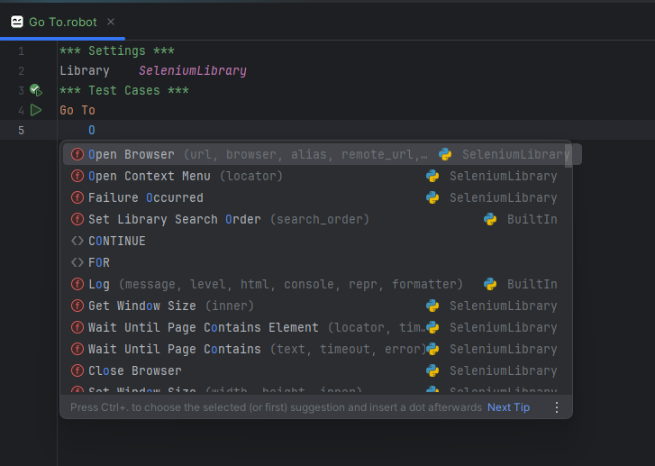

|  |  |
| --- | --- |
| **SeleniumLibrary** | Open Browser, Click Element, Input Text |

|  |  |
| --- | --- |
| **RequestsLibrary** | GET, POST, Create Session |

|  |  |
| --- | --- |
| **DatabaseLibrary** | Connect To Database, Execute SQL Script |

|  |  |
| --- | --- |
| **BuiltIn** | Log, Should Be Equal, Run Keyword If |
|  |  |
|  | 3.Makes Tests Readable and High-Level  Using Library makes your test cases look like business scenarios, not code format.  Example |

Benefits

Save Time, Clean Syntax, Add or Remove libraries (Easy to make another library)

**Step 4 Python Libraries / Tools**

Robot Framework itself is just an automation engine. To do actual tasks (like opening a browser, calling APIs, or working with a database), it uses python libraries.

### 4.1 ****SeleniumLibrary → uses →**** selenium ****(Python module)****

📌 **Goal:** Automate web browsers (open URL, click buttons, fill forms, etc.)

### Under the Hood:

SeleniumLibrary is a wrapper built on top of the selenium Python package.

**Robot Code:**

Robot

Copy code

Open Browser https://google.com chrome

Click Button name=btnK

**What Really Happens:** Behind the scenes, it runs Python code like:

Python

Copy code

from selenium import webdriver

driver = webdriver.Chrome ()

driver.get("https://google.com")

### ****4.2 RequestsLibrary → uses →**** requests ****(Python module)****

📌 **Goal:** Test REST APIs (GET, POST, etc.)

**Robot Code:**

robot

Copy code

Create Session myapi https://jsonplaceholder.typicode.com

GET myapi /posts/1

**What Really Happens:** Behind the scenes, it's like:

python

Copy code

import requests

response = requests.get("https://jsonplaceholder.typicode.com/posts/1")

💡 RequestsLibrary simply wraps the requests Python library with easy Robot keyword

### ****4.3 DatabaseLibrary → uses → Python DB drivers (e.g.,**** sqlite3****,**** mysql.connector****)****

📌 **Goal:** Connect to databases, run SQL queries

**Robot Code:**

robot

Copy code

Connect To Database pymysql dbname username password host

Execute SQL String SELECT * FROM users

**What Really Happens (Python)?**

python

Copy code

import mysql.connector

conn = mysql.connector. Connect(user='username', password='password', host='localhost', database='dbname')

cursor = conn.cursor ()

cursor.execute("SELECT * FROM users")

The Robot keyword just makes it **cleaner and reusable**.

## ✅ Summary Table

| **Task Type** | **Robot Library** | **Python Tool Used** | **Real Purpose** |
| --- | --- | --- | --- |
| Web Automation | SeleniumLibrary | selenium module | Control browsers (Chrome, etc.) |
| API Testing | RequestsLibrary | requests module | Send GET, POST, etc. |
| Database Testing | DatabaseLibrary | sqlite3, mysql.connector | Run SQL queries |

**Step 5 System under Test (SUT)**

The System under Test (SUT) is the actual software or components you’re testing.

It is target of your test cases – where you want to check whether things work as expected.

How Robot Framework Interacts with SUT

For Example

* Web Testing (with SeleniumLibrary):
* SUT: Your Website (<http://www.google.com>)
* Library: SeleniumLibrary
* Tools used : selenium python module

*** Test Cases ***

Login Test

Open Browser https://example.com/login chrome

Input Text id=username myuser

Input Text id=password mypass

Click Button id=loginBtn

* API Testing (with RequestLibrary)
  + SUT: A Rest API (e.g. <https://api.example.com/users>)
  + Library: RequestLibrary
  + Tool used: request Python module

*** Test Cases ***

Get User Info

Create Session myapi https://api.example.com

GET myapi /users/123

# 4. Installation and configuration.

* Install Python
* Install PIP (Performance Improvement Plan)
* Install PyCharm or RIDE IDE
* Install Selenium. (Using PIP)
* Install Robot Framework Selenium Library.(using PIP)
* Enable plugin IntelliBot SeleniumLibrary in the Pycharm. (Write robot framework we use test cases to given Open Browser give it will open the browser.This all process happen keyword suggest in the code by plugin).
* Install Selenium, Robot Framework and Robot Framework Selenium Library in the Pycharm interpreter.
  + - * Selenium Library is access to allow in web Application

# 4.1 Installation Commands

* Python -m pip install
* pip install selenium
* pip install robotframework
* pip install robotframework-seleniumlibary

If python install

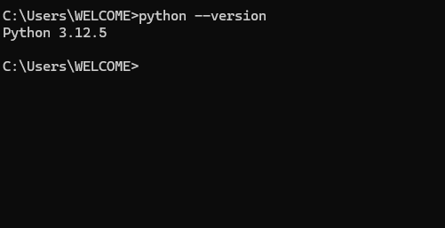1

pip install or python -m pip install

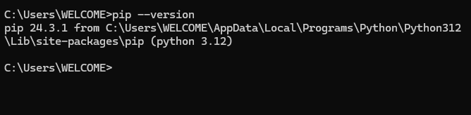

Download Pycharm Community Edition

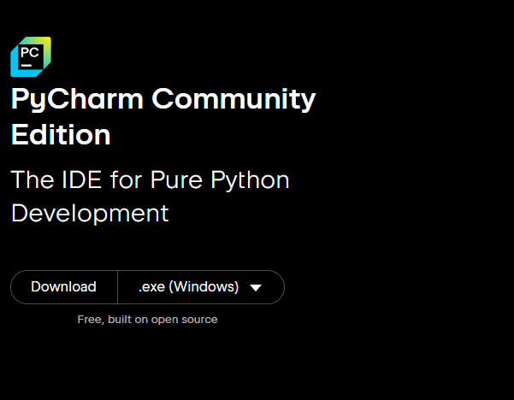

Install selenium

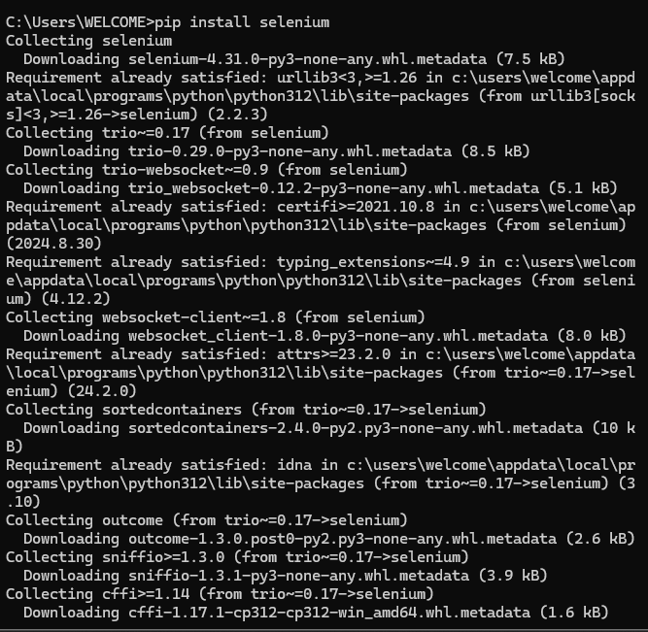

Install Robot framework

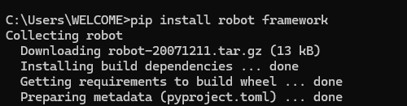

pip install robotframework-seleniumlibrary

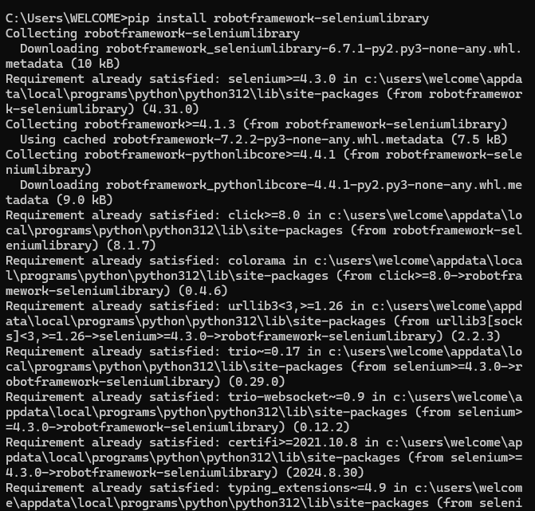

Enable Plugin IntelliBot Framework and Robot Framework Selenium Library (Plugin to suggest to keyword like open and close the window)

Pycharm open settings ----- plugin search install intellibot.

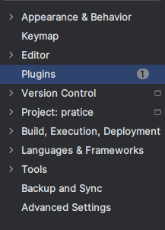

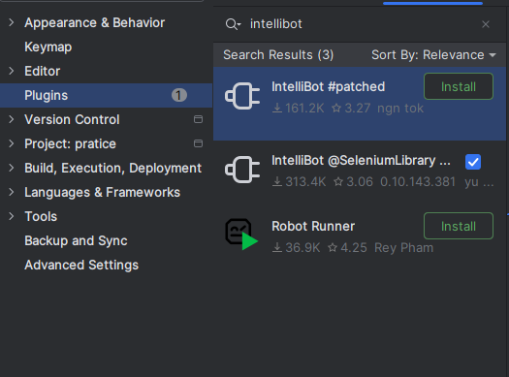

**Create a new project in PyCharm**

Target the project name and click right click

Click New….

Click New File…

Give name sample. robot

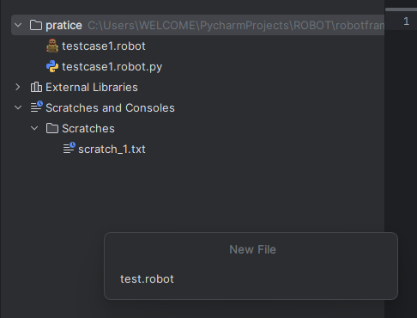 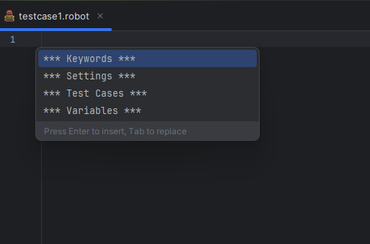

Ctrl + space

# 5. Write the First Test

Open pycharm

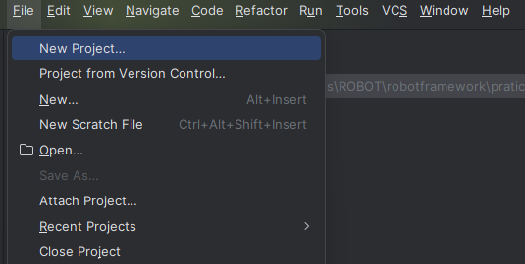 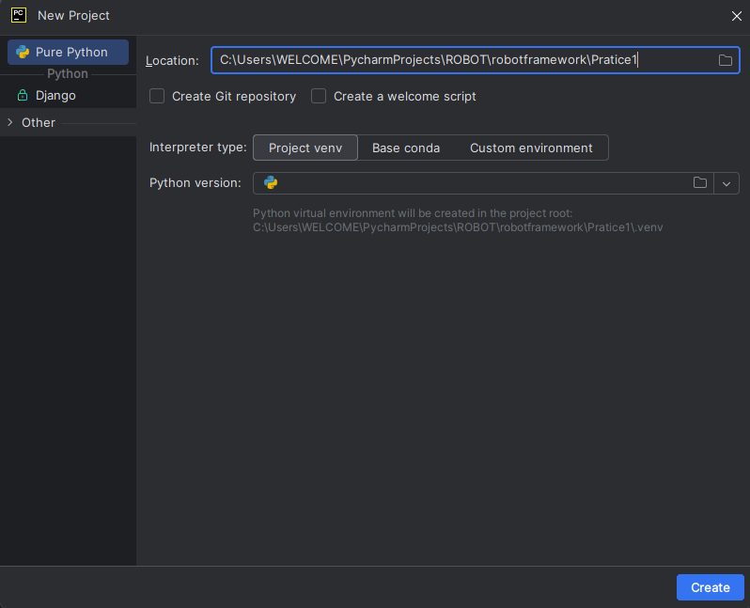

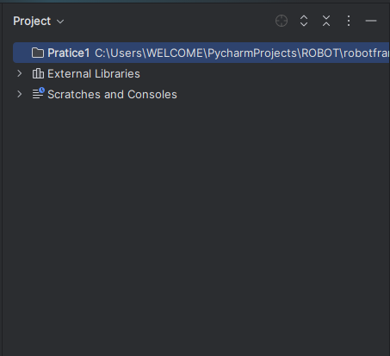 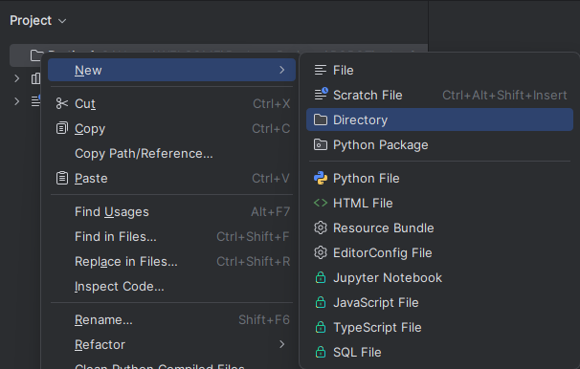

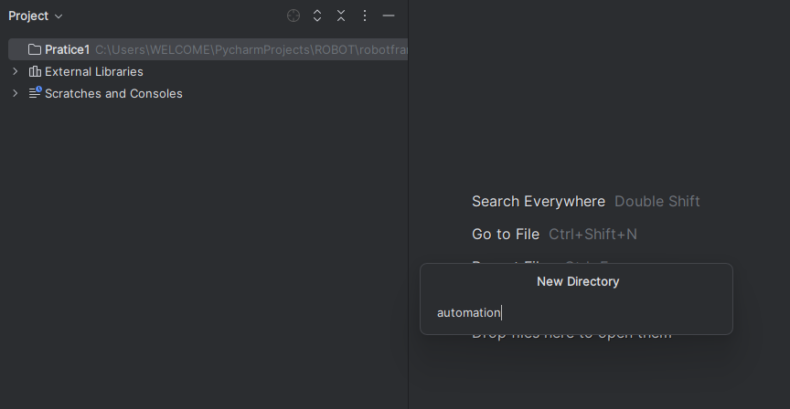

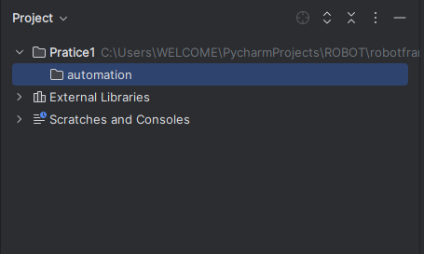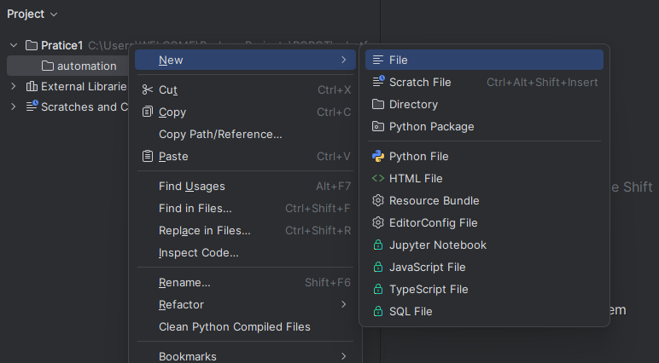

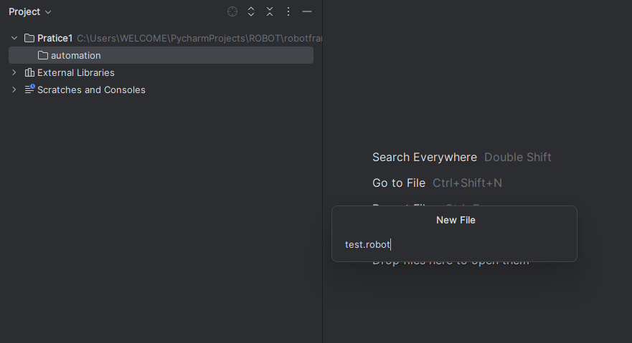 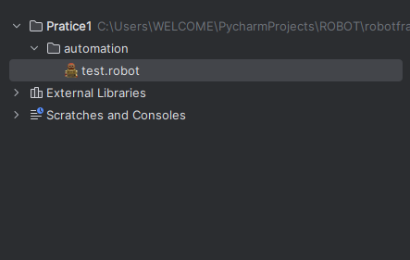

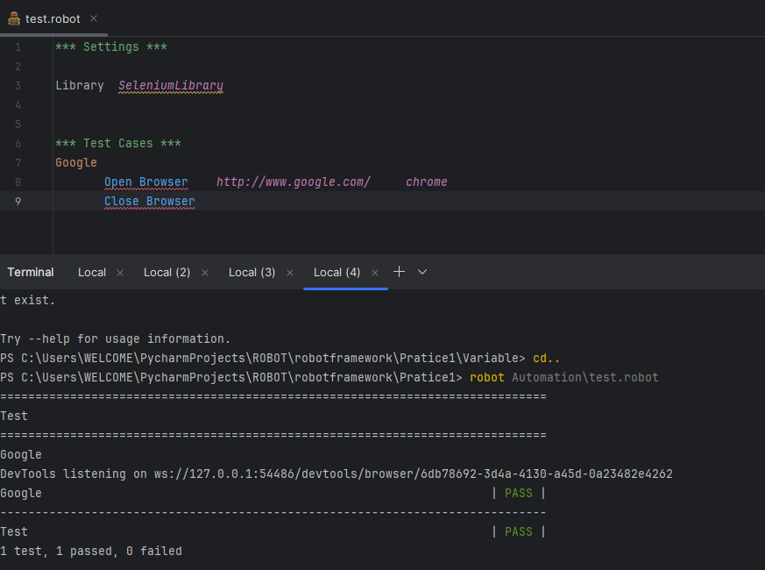



Path _ name > robot [Folder_name] \ file_name.robot

Why use Seleniumlibrary?

It is a test automation Library for web applications

| **Keyword** | **Description** |
| --- | --- |
| Open Browser | Launches a browser |
| Input Text | Types into an input field |
| Click Button | Clicks a button |
| Go To | Navigates to a URL |
| Wait Until Element Is Visible | Waits for element to load |
| Close Browser | Closes the browser |

# 

# 6. Test data syntax

Robot Framework uses a tabular syntax written in text format (.robot)

The term **"tabular syntax"** means that test cases and other elements are written in

**Table-like format**

# 6.1 Test data Section

1. Settings
   1. Importing test libraries, resources files and variable files

b) Defining metadata for test suites and test case

1. Variables
   1. Defining variables that can be used in the test data
2. Test Cases
   1. Creating test cases from an available keywords
3. Tasks
   1. Creating task using available keywords. Either tests or tasks.
4. Keywords
   1. Creating user keywords from existing lower-level keywords
5. Comments
   1. Additional comments or data. Ignored by Robot Framework

1. Test Libraries
   1. Importing Libraries

Test libraries are typically imported using the library setting, or Import Library Keyword

**Using Library setting**

Library are normally imported in the Settings section using the Library settings with the library name or path.

*** (space) Name (space) ***

*** Settings ***

We will declare library

To import external Libraries, resources files, variable and metadata.

Library---seleniumLibrary, operating System

Resources ---include other .robot or .resources (reuse the code)

Suite setup/ teardown, test setup/teardown

***Variables***

To define reusable values in one Place

What goes?

Link or some other resources

Strings

Numbers

Lists

Dictionaries

`*** Variables *** (reuse the code)

${URL} https://www.google.com

${BROWSER} chrome

***Keywords***

To define custom Keywords (Your own reusable logic)

*** Keywords ***

Open Google

Open Browser ${URL} ${BROWSER}

Close Browser

Close Browser

*** Test Cases ***

To define actual test scenarios

*** Test Cases ***

Individual Example

Open Google

Sleep 2s

Close Browser

Why use this type of *** Asterisks?

Clearly making the start of a new section.

Helping both human reader and the Robot Framework interpreter easily recognize sections.

Making the structure visually clean and organized.

*** Asterisks strictly required

Use * settings *

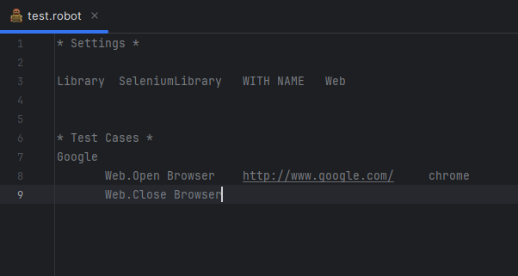

It is understandable, but Robot framework requires section header.

But give *settings* it look like a comment section (*setting*) in python #hello

Settings and Test Cases keyword Mandatory because without them, we won’t be able to execute any Robot Framework.

# 

# 7. Settings

# 7.1 Intro

I) Test libraries

2) Resources Files

3) Variable files

1. Using Test Libraries

Testing Libraries contain those lowest-level Keywords called library keyword

Lowest-level (Keywords are not created by user. It is default like SeleniumLibrary, Built - in, Operating System, String, Collection, Time Date, etc.)

All Test cases always use keywords from some library.

7.1) Importing Library

Test Libraries are typically imported using the Library settings

*** Settings ***

Library path

### 7.1.1 Using Library settings

Libraries are normally imported in the settings section using Library settings with the library name or path.

Library name or path is both case and space sensitive.

*** Settings ***

Library OperatingSystem

Library path/to/MyLibrary.py

Library filename.robot

Library ${LIBRARY}

What are benefits the ***settings***

1. Library seleniumLibrary
2. Library seleniumLibrary WITH NAME Web
3. Imported an Other Resources File
4. Basic Library Import

Syntax

*** Settings ***

Library LibraryName

Example

*** Settings ***

(Whitespaces important in robot framework)

Library SeleniumLibrary

*** Test Cases ***

Open Browser (Tab Space) link (Tab Space) Browser (chrome, Firefox...)

Open Browser <http://www.google.com> chrome

Close Browser

1. Library Import with Alias (With name)

You can give a library a custom name using with name

Example

*** Settings ***

Library SeleniumLibrary WITH NAME Web

*** Test Cases ***

Google

Web. Open Browser <http://www.google.com/> chrome

Web. Close Browser

**BuildIn Library (Both same)**

**With Library**

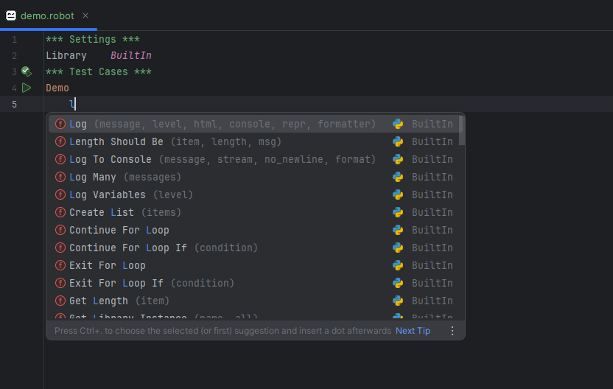

**Without Library**

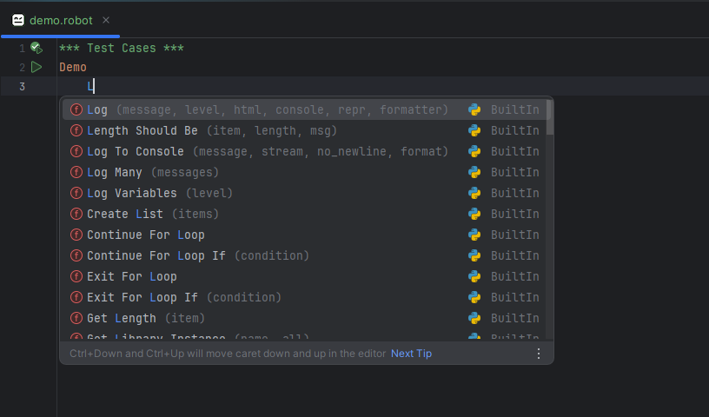

### 7.1.1.1 Library OperatingSystem

It is a build-in library that allows you to interact with your Computer Operating System.

To perform basic file and directory operations, run shell, system commands and interact with the os environment.

It work like CRUD.

1) To Run a Shell Command

Create one Directory

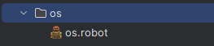 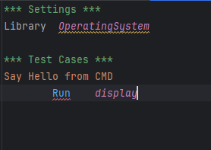

Output code

Run [Argument] ----GIVE one argument

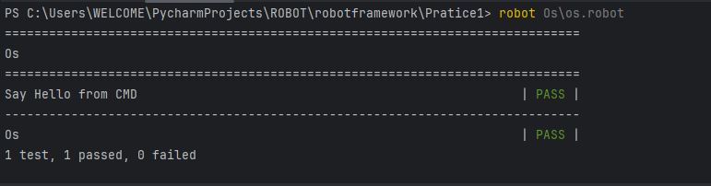

1. Check if a File Exists or not (File is available or not)

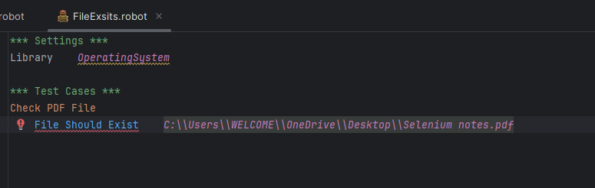

C:\Users\WELCOME\OneDrive\Desktop\Selenium notes.pdf --- - Give Error

### C:\\Users\\WELCOME\\OneDrive\\Desktop\\Selenium notes.pdf -----Output given…Screenshot 2025-04-07 161250

1. create and delete the folder

I) create

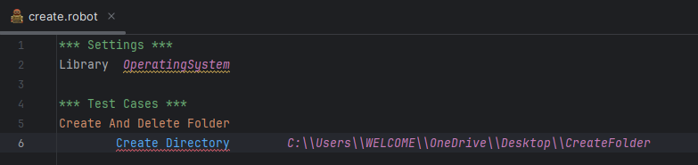

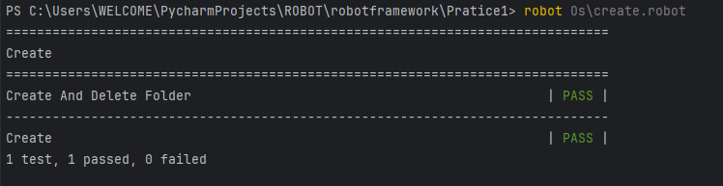

ii) Remove

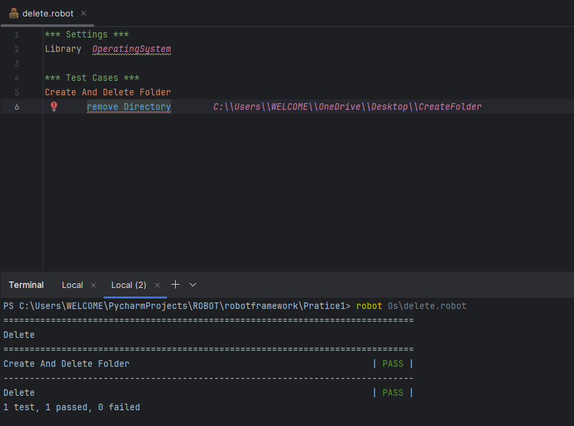

1. Rename a File in same Folder

Work Later (Some issue)

### 7.1.2.2 Resources Files

Library test login.robot

Reusable the code

Common Keywords, variable and settings can be defines once and reused in multiple test cases or test suites.

Test suites

In software testing, a test suite is a Structured collection of test cases to verify behaviors, components of a software application, execution and reporting of test results.

Test cases

Input situation, steps to execute, test a specific features of a software.

Test Scripts

Commands that are needed to execute a test case .Utilized to automate the testing activities

Test Data

Set of inputs required at the time of test execution. They play a very important role in verifying multiple scenarios and situation.

Characteristics of a test suite

* Developed first the module or application after testing developed a test plan
* There are test cases like (login, signup, etc.…)
* Test parameters like application , environment , version , others
* These can be created based on the test cycle.
* Kinds of testing including functional testing and nonfunctional testing.
* Way to test and evaluate the application quickly.
* It may be used with many automation testing tools.

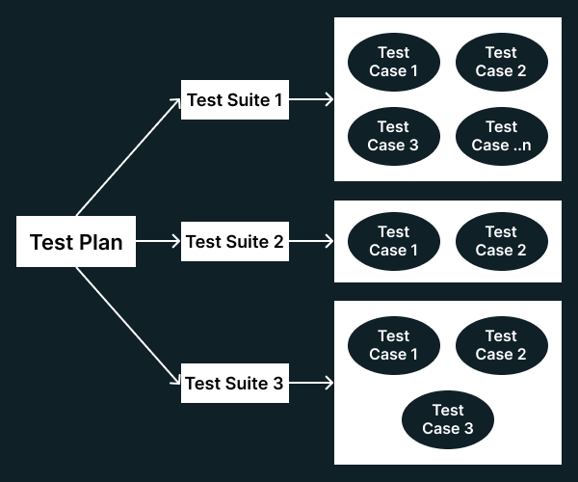

* Easier to update and maintain
* Easier for teams to collaborate with the code is organized and structure.

Example for Test Plan

Test Plan: E-Commerce Website Testing

Test Suite 1: User Registration & Login

* Test Case 1: Verify successful registration with valid details.
* Test Case 2: Verify error on registration with an already registered email.
* Test Case 3: Verify login with valid credentials.
* Test Case 4: Verify error on login with incorrect password.

Test Suite 2: Product Search & Filter

* Test Case 1: Verify product search by name.
* Test Case 2: Verify filter by price range.
* Test Case 3: Verify filter by brand.
* Test Case 4: Verify no results for a non-existent product.

Test Suite 3: Cart & Checkout

* Test Case 1: Verify adding a product to the cart.
* Test Case 2: Verify updating quantity in the cart.
* Test Case 3: Verify removing a product from the cart
* Test Case 4: Verify successful checkout valid payment details.

Example for Resources File Import

Open cricbuzz website

Directly go on Schedule matches.

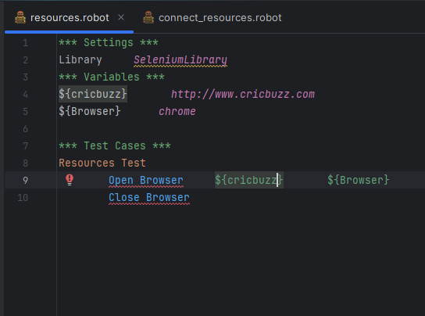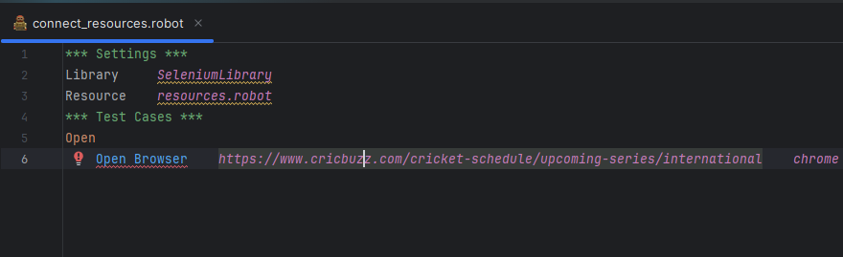

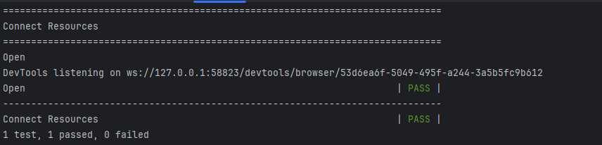

### 7.1.2.3 Variable file

In Robot Framework, a variable file is a python (.py) file used to define variables that you can reuse across multiple test suites.

To manage read from files or use Python logic.

Example

Using String

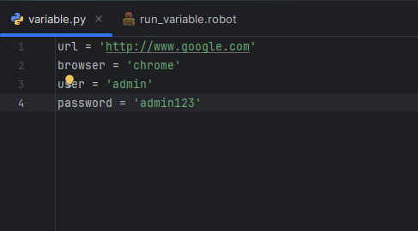

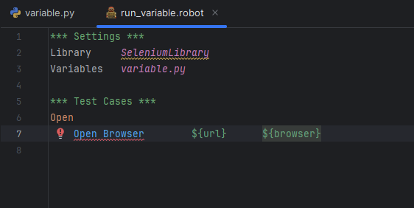

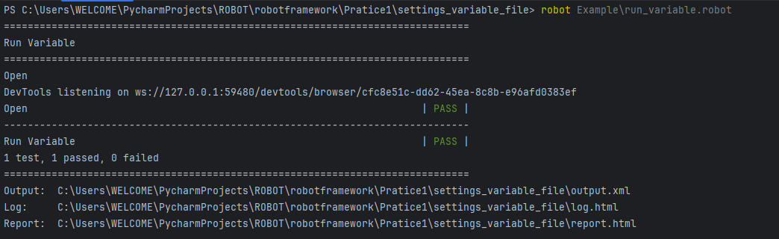

When to use a Variable File

1. Need Dynamic Variable (Calculate at runtime)

**How to check run time (.robot) file**

Top Program Example

Code run

robot Example\name. robot

It give

* Output
* Log (Test Status)
* Report (summary Information)

1. You want many variables outside to connect .robot files.
2. You want to read config data from JSON,CSV or environment

Check Run Time

import os  
from robot import run  
run ('Example/run_variable.robot')

Some error

Variable file using dictionary and list

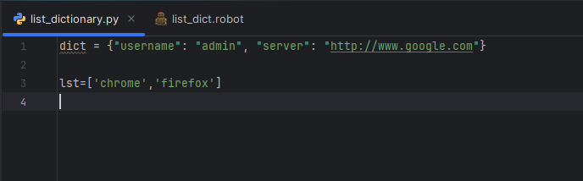

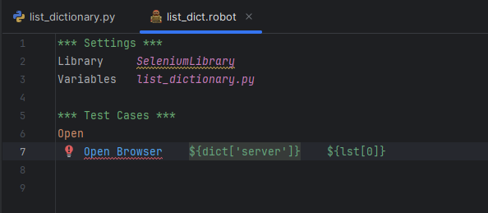

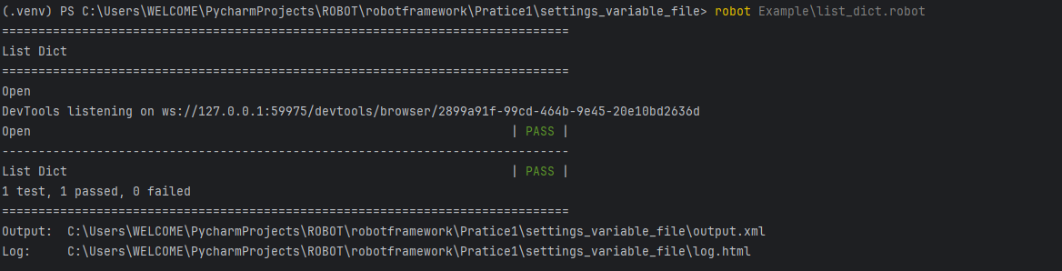

| **Feature** | **Library** | **Resource** | **Variable File** |
| --- | --- | --- | --- |
| Purpose | Adds functionality | Reuse keywords/settings | Centralize variables |
| File type | .py, built-in, external | .robot | .py or .robot |
| Contains | Keywords (built-in/custom) | Variables & Keywords | Only Variables |
| Example | Library SeleniumLibrary | Resource keywords.robot | Variables data.py |

| **Library** | **Why Use It** | **Example** |
| --- | --- | --- |
| **BuiltIn** | Default library with basic keywords like Log, Sleep, Should Be Equal | Library BuiltIn |
| **SeleniumLibrary** | Automate web browser interactions | Library SeleniumLibrary |
| **Collections** | Handle lists, dictionaries, etc. | Library Collections |
| **OperatingSystem** | Work with files and system commands | Library OperatingSystem |
| **String** | String manipulation and checking | Library String |
| **Date Time** | Date and time handling | Library DateTime |
| **Screenshot** | Take screenshots (e.g., for failed tests) | Library Screenshot |
| **RequestsLibrary** | For REST API testing | Library RequestsLibrary |
| **SSHLibrary** | For executing commands over SSH | Library SSHLibrary |
| **Dialogs** | Create simple GUI dialogs | Library Dialogs |

# 8. Variables

In Robot Framework ***Variable*** is a Section used to define variable that can be reused throughout the test cases and keywords.

Defining [variables](https://robotframework.org/robotframework/latest/RobotFrameworkUserGuide.html#variables) that can be used elsewhere in the test data.

Variables name used most place in test cases

Why use ***variable***

1. Reusability
   1. You can define a value once and use it in multiple Places.
   2. This avoids hardcoding values repeatedly.

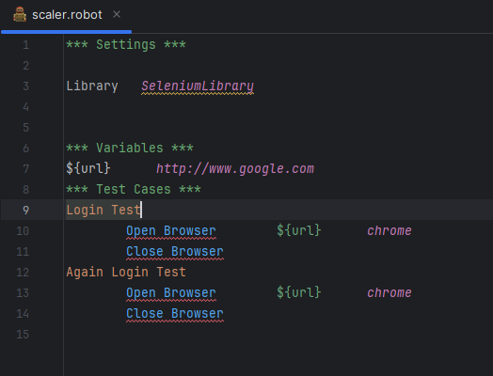

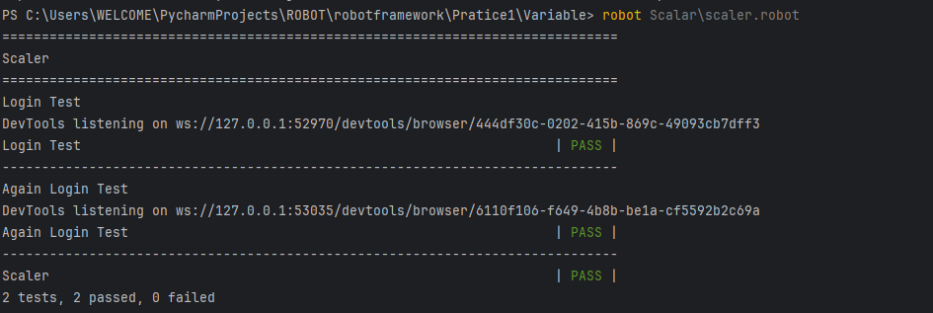

1. Maintainability
   1. If a value change (e.g. the url), you only need to update it in one place instead of updating every test case
2. Readability
   1. Using descriptive variable names makes your test cases easier to read and understand

Variables that can be used

| **Type** | **Syntax** | **Description** |
| --- | --- | --- |
| Scalar | ${VAR} | Holds a single value |
| List | @{VAR} | Holds multiple values (list) |
| Dictionary | &{VAR} | Key-value pairs (dictionary/map) |

Log Keyword is used to print the message

# 8.1 Variables write ways

8.1.1 Scaler

Syntax: ${Variable}

Holds a single value (string, number, etc...)

Return string

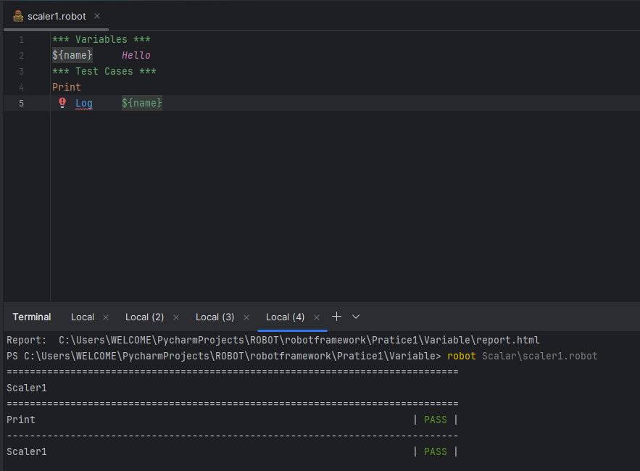

#Hyper framework support ---->settings>>plugin>>>

To remove red line

8.1.2 List

Syntax: @ {Variable}

Use: list of values (multiple items)

Return list as a string

Maximum we use ${name} because we will single value (list method) in @{name}

Why because all variable method single value

For example

@ {lst} ------ Apple Banana

Log @ {lst}

>>>>>>>>>>> .Apple

All the output return means we use for loop condition

Or

@ {lst} ------ Apple Banana

Log ${lst}[0]

>>>>>>..Apple

Log ${lst}[1]

>>>>>>Banana

Log To Console ----- Output will print in Terminal

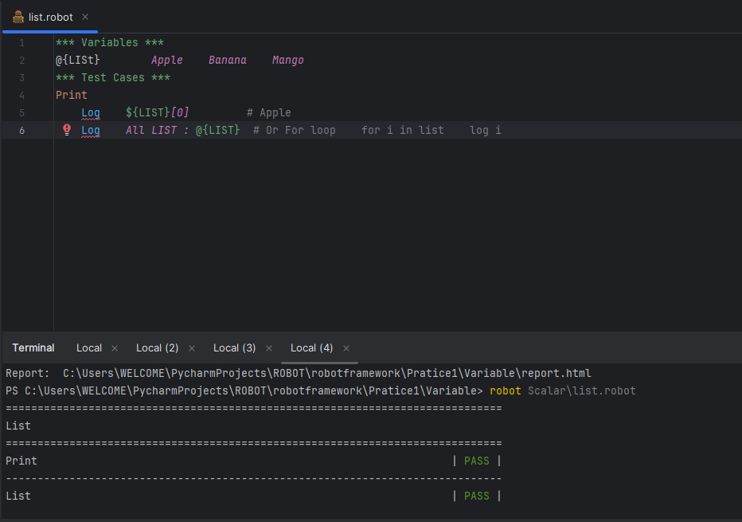

8.1.3 Dictionary

Syntax: & {variable}

Use: Key and value pair

Return {'name': 'Deepan', 'email': 'deepan@gmail.com'}

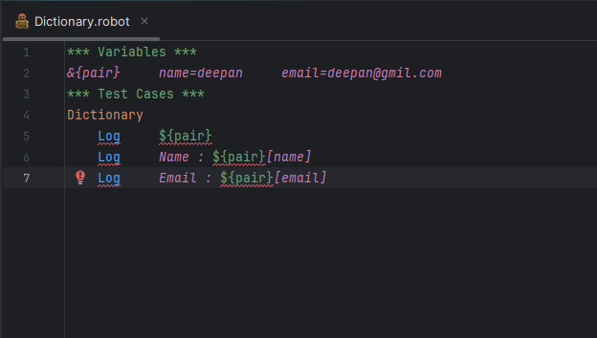

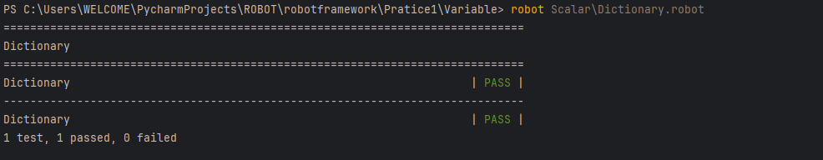

Why not use in log & {pair}

Because In Robot Framework, You cannot use & {dict} directly with the Log Keyword.

Log expects a scalar string message

Suppose we use

***Variables***

& {dict} name=deepan password=deepan123

***Test Cases***

Log To Console @ {dict}

>>>>>>>return only first key value name

Log To Console ${dict}[name]

>>>>>>deepan

Log To Console ${dict}[password]

>>>>>>deepan1411

### 8.1.4 Environment Variable

### Access system environment Variable

### Syntax %{ Env_variable_name}

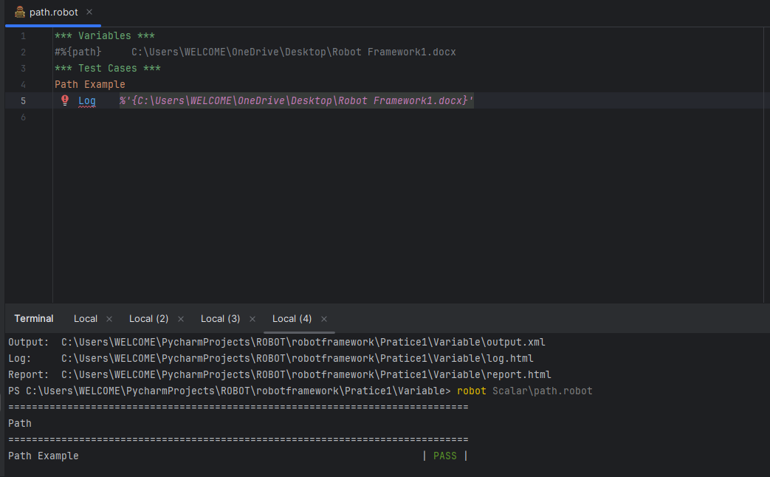

# 8.2 Creating Variable or Custom variable

Example

Suppose value assign individual variable and assign individual same variable return to print in test cases

Output given or not to Check

Some Error in List and Dictionary

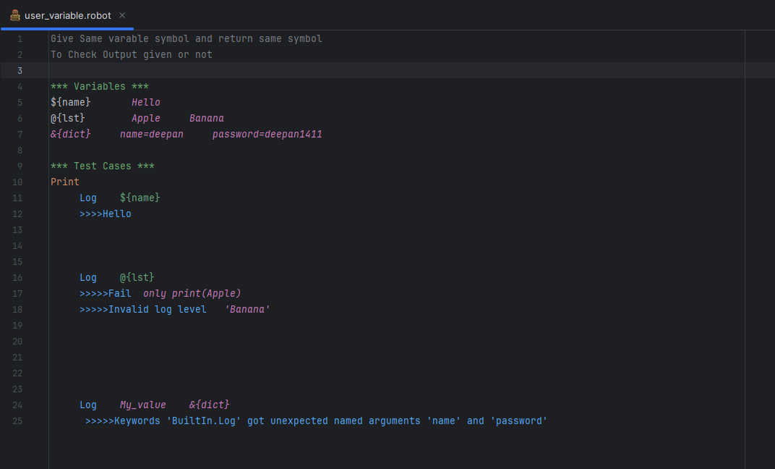

Log To Console output in terminal

To Check return all the variables in Scaler method

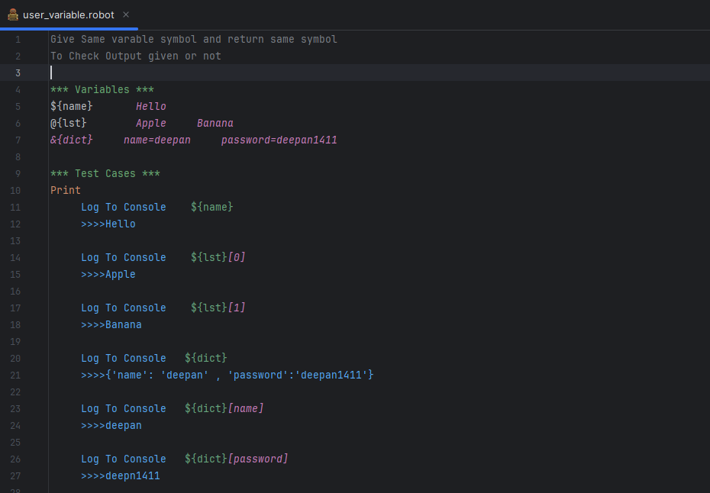

Build - in variables or Advances Topic in Variables Section

1. Number variable (Evaluate)

The variable syntax can be used for creating both integers and floating point numbers.

Number not give like a string, just looks like a number

For Example ‘10’----Not give

10 ----Correct

Add, subtract, divided, modules etc.…..

Calculate the argument to use one keyword called Evaluate, Should Be Equal

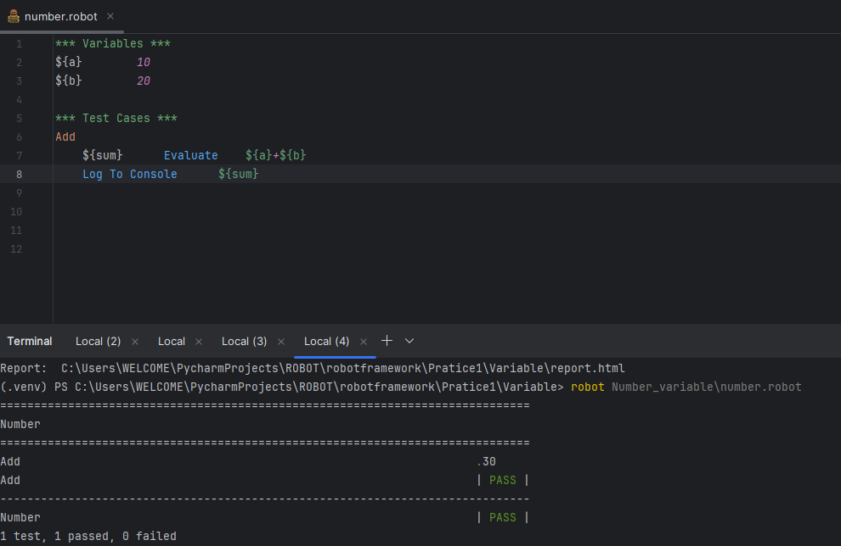

1. Two value or same or not

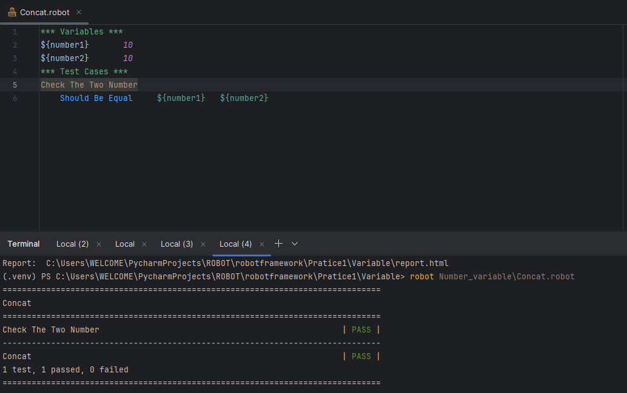

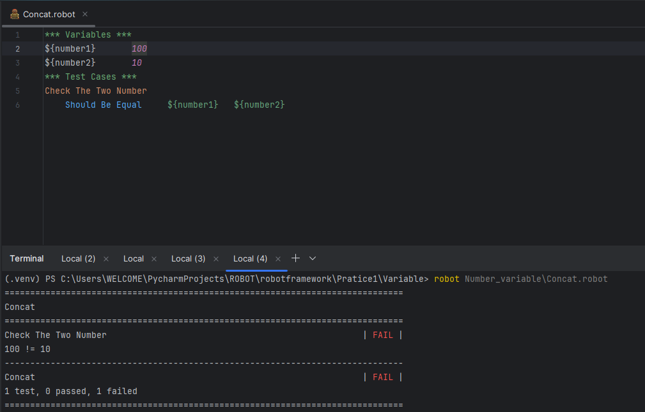

1. Automatic Variable
2. Test Name (Give the test name)

*** Test Cases ***

Test Name -------------> This Line called Test Name

Log User input

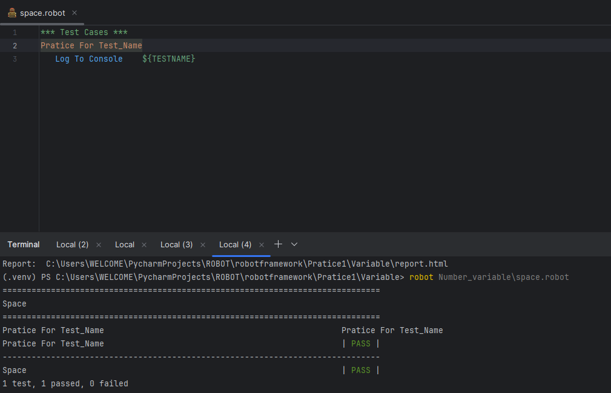

1. output Directory

Return current directory file

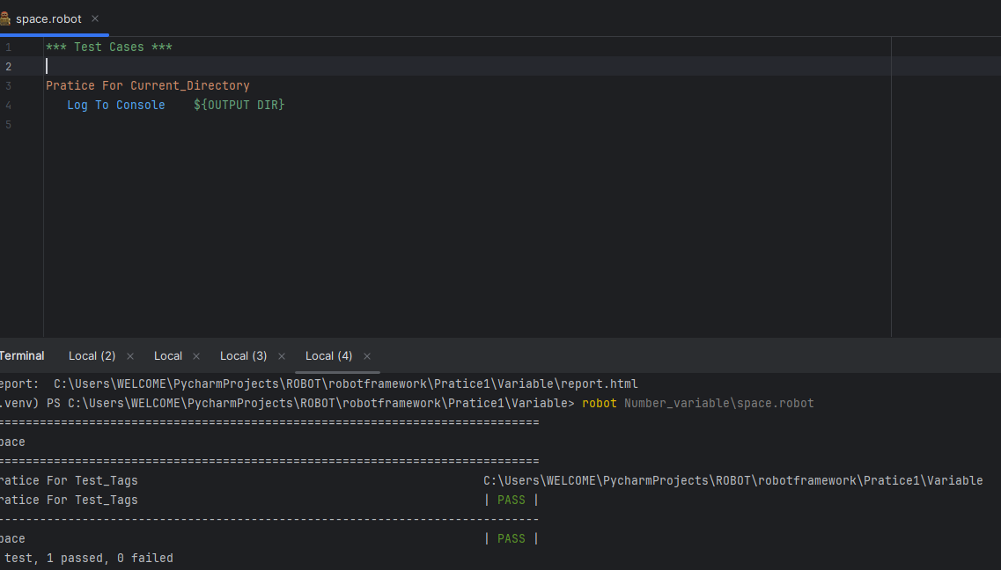

### 8.2.1 Creating Variable

The Simplest Possible variable assignment.

1. Normal Method assign a Variables

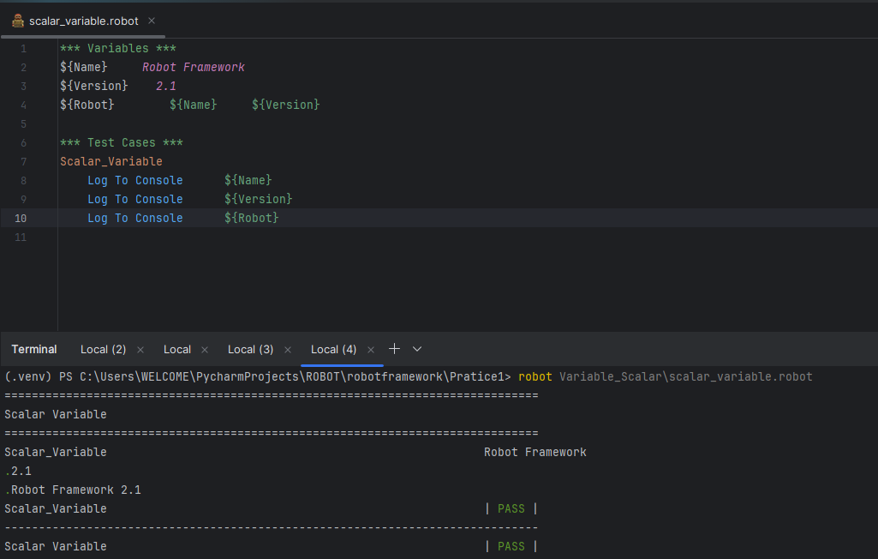

1. Assign a variable by using =

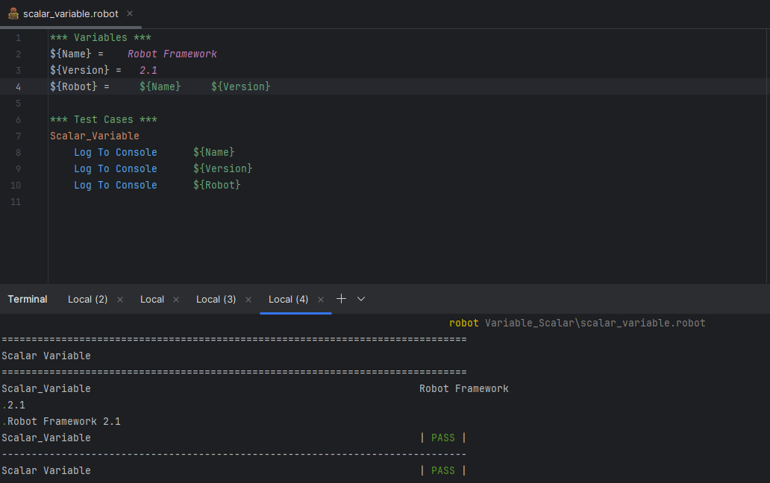

1. Assign Multiple Line by using (…)

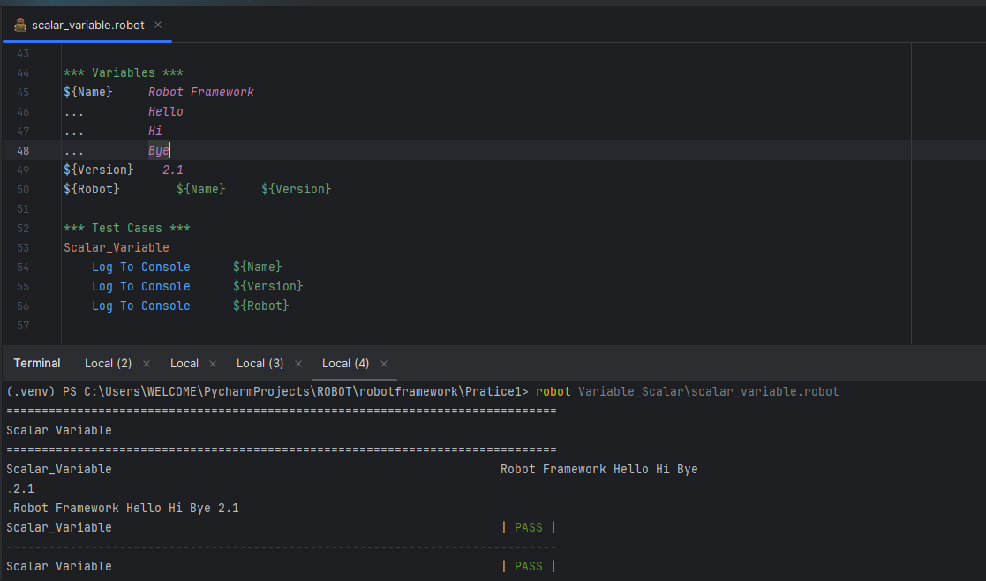

# 9. Test Case Section

In Robot Framework, the ***Test Cases *** section is where you define individual test scenarios. Each test case describes a set of steps or actions that will be verify a particular feature or function of your application.

**What is Scenario?**

Testing the application in all possible ways is called Scenario. There are two types

1) Positive Scenario

2) Negative Scenario

1. Positive Scenario

Testing the application with valid (or) expected is called Positive Scenario.

1. Negative Scenario

Testing the application with invalid (or) unexpected data is called Negative Scenario.

**What is Test Case?**

Test case is a document which contain scenario and explain step by step process.

Test Case we have different templates Change by Company and project.

Automation Test Case Scripts

*** Test Cases ***

Valid Login Test

[Documentation] Test user login with valid credentials

Open Browser ${URL} chrome

Input Text id=username ${USERNAME}

Input Text id=password ${PASSWORD}

Click Button id=login

Page Should Contain Element id=dashboard

Close Browser

In Basic Structure of robot framework

***Test Cases***

Test Case Name

Step 1

Step 2

….

….

Each test case start with name and step contain series of keyword.

# 10. Keywords section

In Robot Framework the keywords section is use define custom actions that can be reused in test cases.

Keywords like functions in python or methods in java. They help to make your test cases clean and easy to understand.

Why Custom Action?

Code simple and clear example of definition keyword.

Robot Framework using Google homepage as the scenario.

1. Open Google
2. Search for something (e.g., "Robot Framework")
3. Verify the results page appears
4. Close the browser

*** Settings ***

Library SeleniumLibrary

*** Variables ***

${GOOGLE} https://www.google.com

${SEARCH_TEXT} Robot Framework

*** Test Cases ***

Google Search Test

Open Google Homepage

Search in Google

Verify Search Results

Close Browser

*** Keywords ***

Open Google Homepage

Open Browser ${GOOGLE} chrome

Maximize Browser Window

Wait Until Page Contains Element name: q 10s

Search In Google

Input Text name: q ${SEARCH_TEXT}

Press Keys name: q RETURN

Verify Search Results

Wait Until Page Contains Robot Framework

Function in keyword

Web driver is web automation script.

Self.variable_name = webdriver.Chrome ()

Self.variable.get(Server link)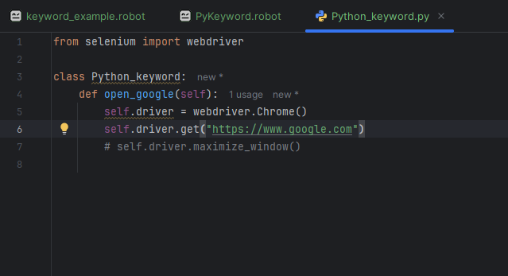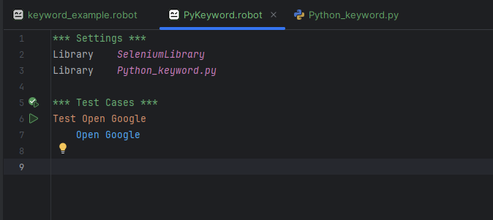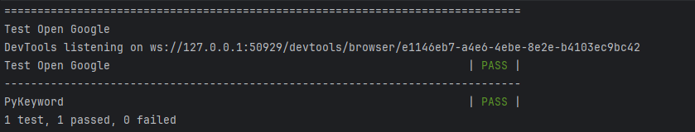

.get (url)

In Selenium, .get(url) is a method used to open a web page in the browser.

It tells the browser to navigate to a specific URL.

For Example

driver.refresh()

driver.back()

driver.forward()

**Three Arguments**

[***Arguments***] ${arg1} ${arg2} ${arg3}

Log 1st argument: ${arg1}

Log 2nd argument: ${arg2}

Log 3rd argument: ${arg3}

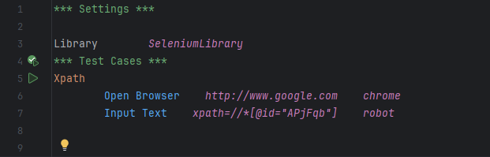

# 10.1 Types of Keywords

There are two types of keywords

1) Build-in or Library keywords

2) User-defined (Custom) Keywords

# 10.1.1 Build-in keywords

These Come with Robot Framework by default – no extra install needed.

No need to import any library.

For example if open browser means no install any things

By default use Open Browser

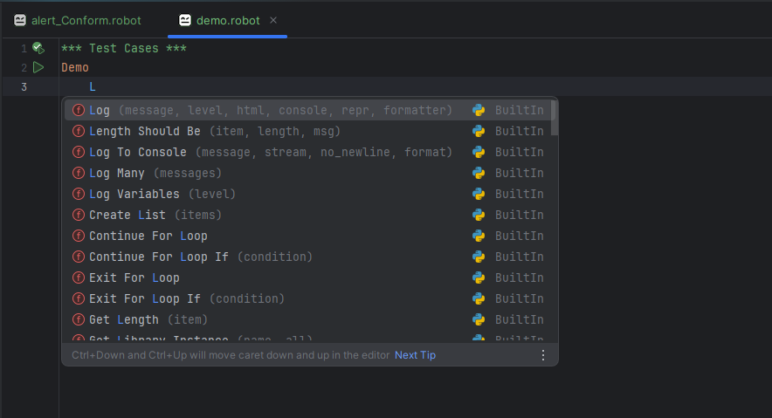

**Important Topics**

They cover:

* **Control structures** (IF, FOR, etc.)
* **Logging**
* **Variables**
* **String handling**
* **Date/time**
* **Error handling**

Example for Keywords

| **Keyword** | **Purpose** |
| --- | --- |
| Log | Logs a message |
| Should Be Equal | Checks if two values are equal |
| Run Keyword If | Runs a keyword conditionally |
| Set Variable | Sets a variable |
| Sleep | Pauses the test |
| Fail | Fails the test |
| Evaluate | Runs Python expressions |
| Length Should Be | Checks the length of a list/string |

10.1.1.1. Log and Log To Console

Log a message in the test report

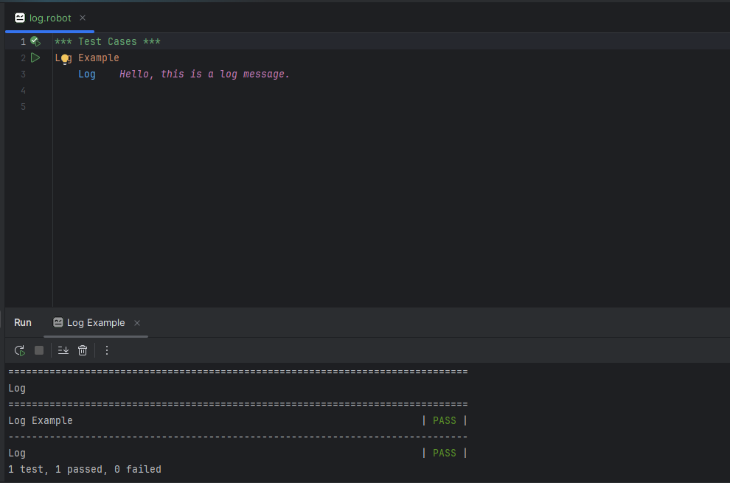

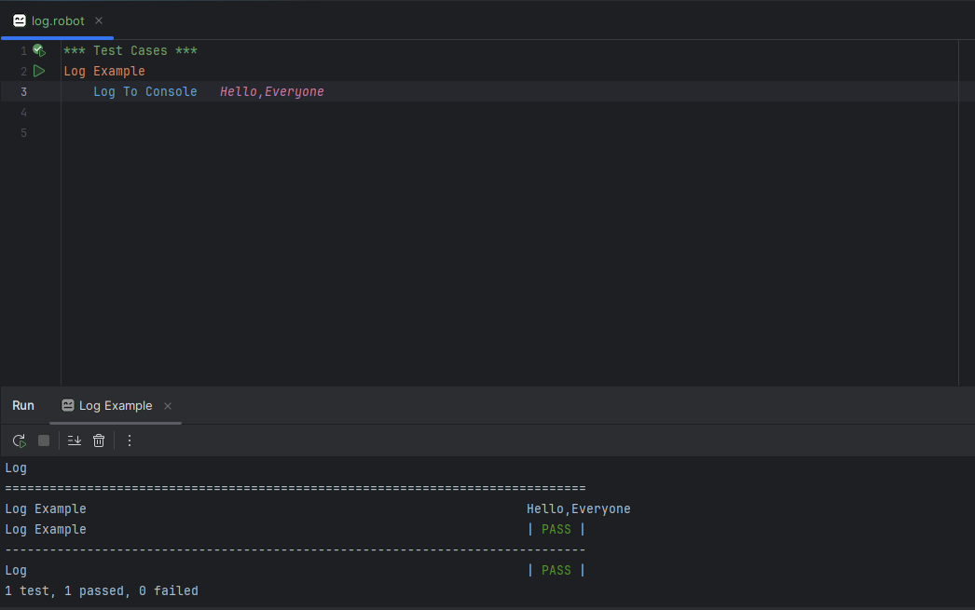

10.1.1.2. Should be equal

Checks if two values are equal

*** Test Cases ***

Should Be Equal Example

Should Be Equal Robot Robot

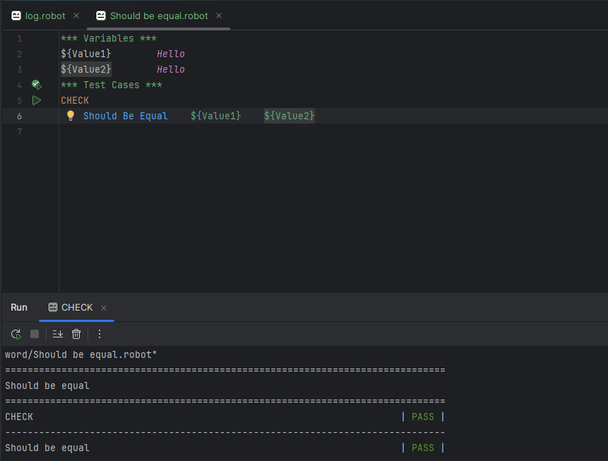

10.1.1.3. Run Keyword If

Check only if Condition.

This Condition not throw error because if condition only given.

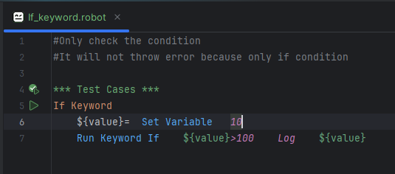

10.1.1.4. Set Variable

Stores a value in a variable.

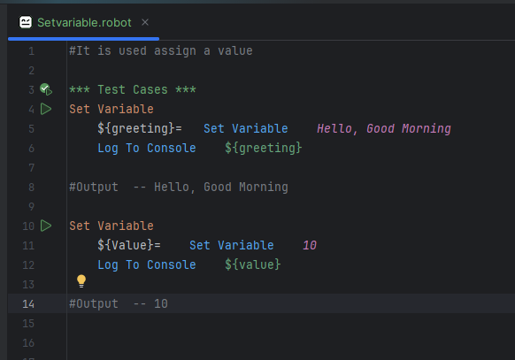

10.1.1.5. Sleep

Pauses the test for a certain time

Syntax

Sleep (time, reason)

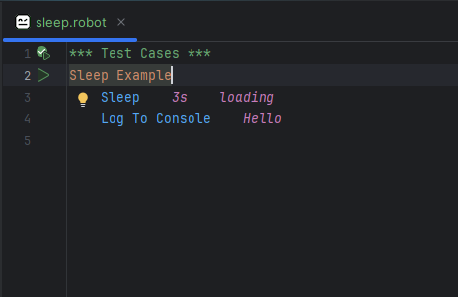

10.1.1.6. Fail

Fails the test with a custom error message

We can custom the error.

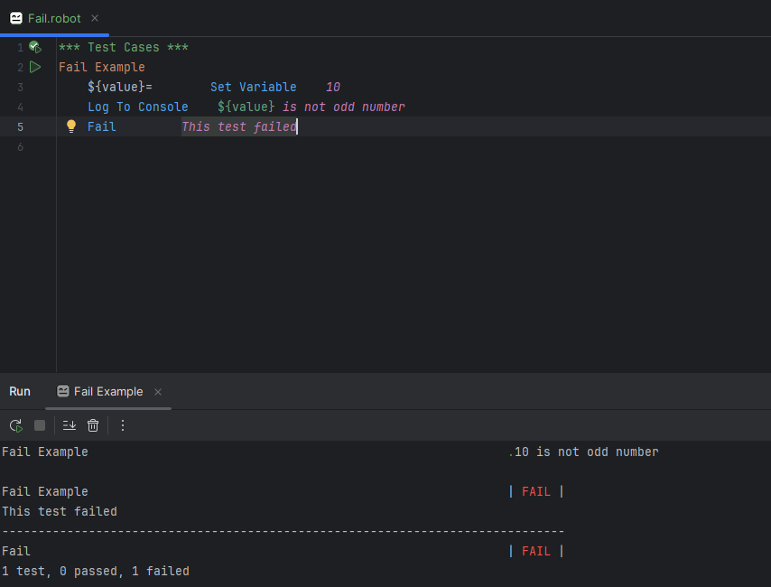

10.1.1.7. Evaluate

Executes Python expressions and return the results

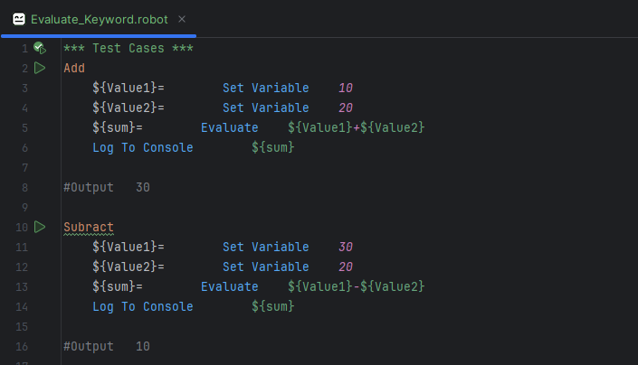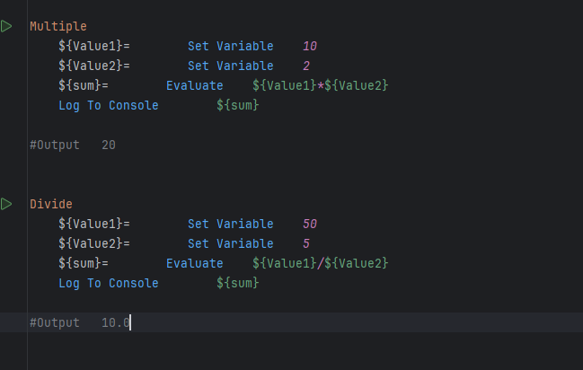

10.1.1.8. Length Should be

Check the length of variable

For Example Hello Length of hello is 5

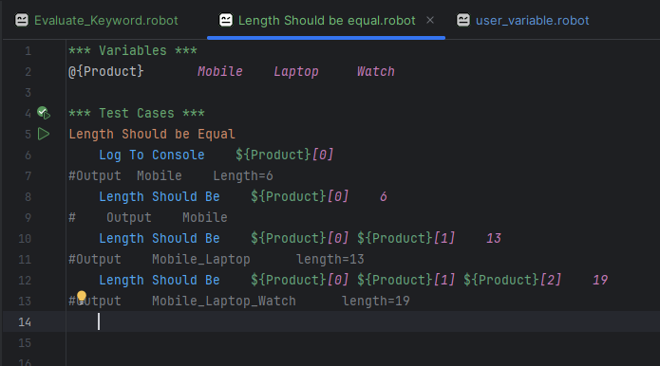

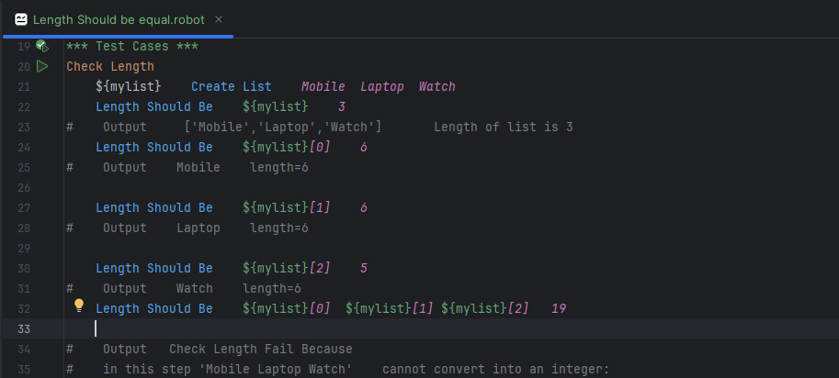

# **10.1.2 User-defined (Custom) Keywords**

User defined keywords also called custom keyword in robot framework are keywords created by the user combining one or more existing keywords (Build in keywords).

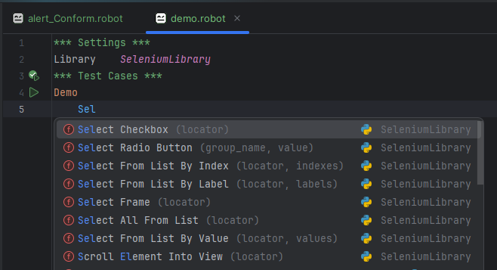

**Why use User defined Keywords.**

1. Reuse code (Avoid Duplicate)

If you have repeated step multiple test cases, you can define then once a custom keyword and reuse.

For Example (only change product)

Go to flipkart check mobile

Go to flipkart check laptop

Go to flipkart check Tab

Go to flipkart check Ac

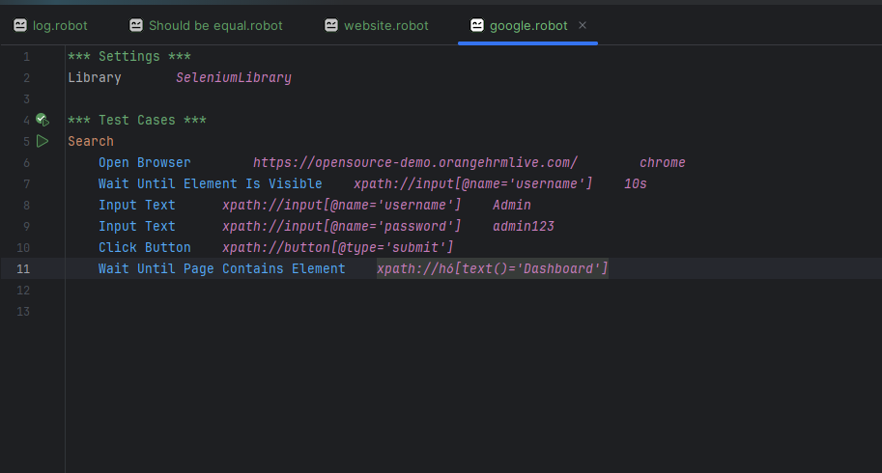

2. Easy Understand

Custom keyword make test cases more readable.

For Example

***Keyword***

Open To Website

Open Browser link chrome

Input Text xpath: id value

Input Text xpath: id value

Close Browser

***Test Cases***

Check

Open To Website

**By Using Keywords and Test cases**

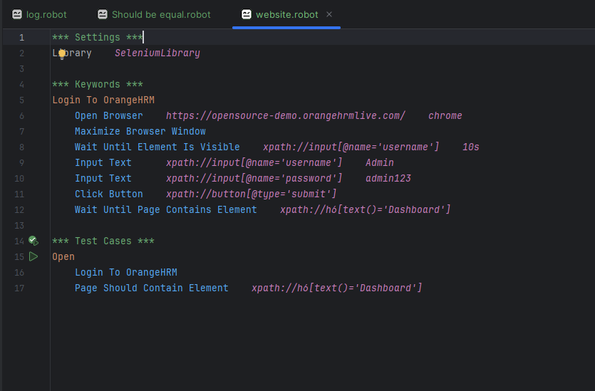

# 11. Locators (Path)

In Robot Framework, Locators are used to identify web elements like buttons, input field, links, etc.

Use Locator Keywords like

* Click Button
* Click Element
* Wait Until Element Is Visible
* Input Text
* Get Text

Common Locator Types

Id Finds element id attributes

Name Finds element name attributes

Class Finds element class

XPath Finds using XPath expression

Xpath=//button [@type='submit']

Link Finds a link (Forgotten Password)

Link=Login

Partial link Find a link containing text. (It will used to Large to set First name only)

Partial link=Sign

Tag Finds tag name (less)

# 12. Commonly used in selenium Keywords

1. Browser Control

2. Element Locators

3. Page Interation

4. Waits & Timing

5. Dropdowns

6. Alerts

# 12.1 Browser Control

Browser Control in Robot Framework refers to openings, closing, maximizing and managing browser windows or tabs during test automation using the SeleniumLibrary.

1. Open Browser

Opens a new browser with a url.

2. Close Browser

Closes the current active browser

3. Close All Browser

Close all open Browser

4. Maximize Browser Windows

Maximizes the current browser window

5. Go To

Navigates to a new URL

6. Get Location

Gets the current url

7. Set Windows Size

Sets the browser windows to a specific size

8. Get Windows Size

Gets the size of the browser window

9. Switch Browser

Switches between multiple open browsers

10. Reload Page

Reloads the current Page

12.1.1 Open Browser

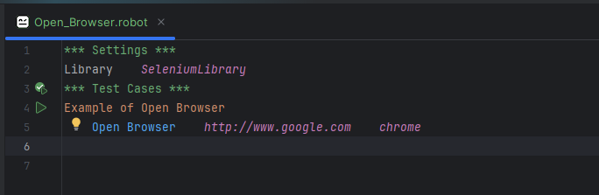

12.1.2 Close Browser

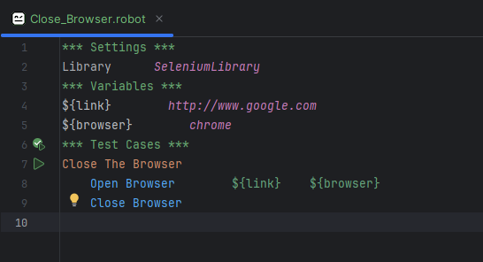

12.1.3 Close All Browser

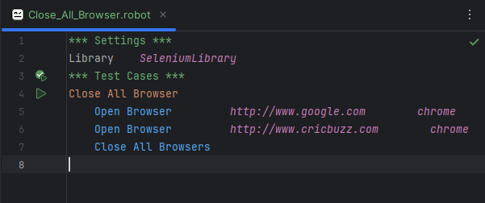

12.1.4 Maximize Browser Windows

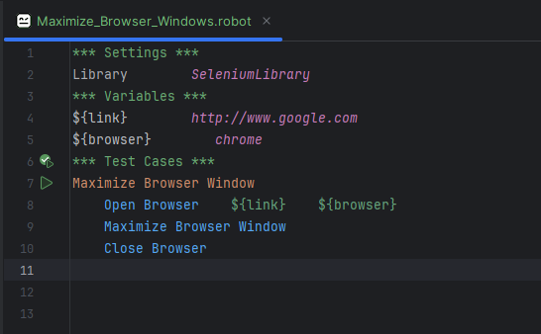

12.1.5 Go To

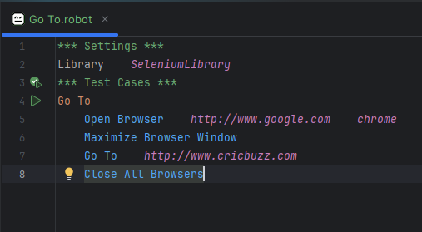

12.1.6 Get Location



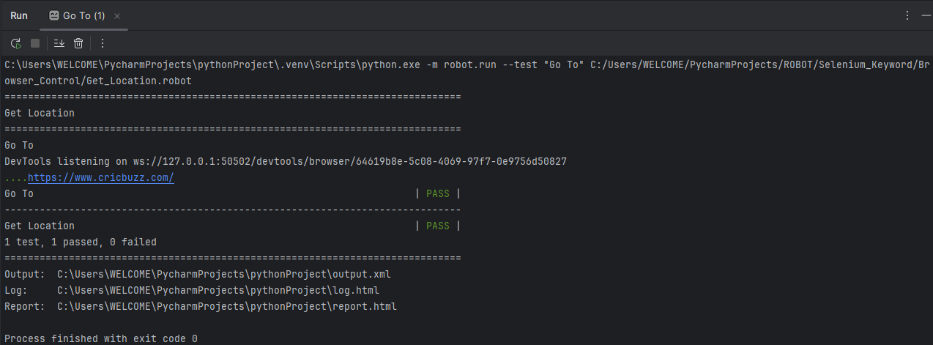

12.1.7 Set Window Size

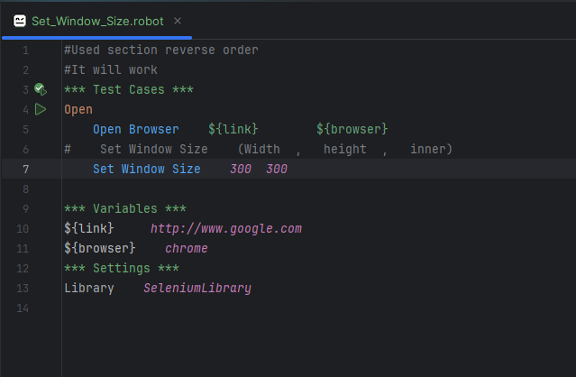

12.1.8 Get Windows Size (Some Problem in Output)

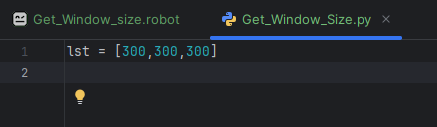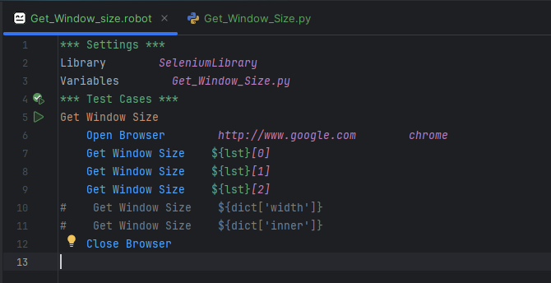

12.1.9 Switch Browser

*** Settings ***

Library SeleniumLibrary

*** Test Cases ***

Switch between Google and Cricbuzz

# Open Google

Open Browser https://www.google.com chrome

Maximize Browser Window

${google handle} = Get Window Handle

# Open Cricbuzz in a new tab using JavaScript

Execute JavaScript window. Open ("https://www.cricbuzz.com", "_blank")

Sleep 2s

${handles}= Get Window Handles

Log ${handles}

# Switch to Cricbuzz (the new tab)

Switch Window handle=${handles [1]}

Sleep 2s

# Do something on Cricbuzz page (optional)

Title Should Contain Cricbuzz

# Switch back to Google

Switch Window handle=${google handle}

Sleep 2s

# Close all browsers

Close All Browsers

12.1.10 Reload Page

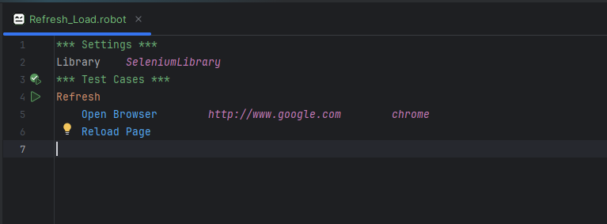

# 12.2 Element Locator in SeleiumLibarry

In robot framework, especially with the selenium Library, you use different element locator types to interact with element on a webpage.

Commonly used locator types

1. ID

Target the id attributes

2. NAME

Target the name attributes

3. CLASS

Target the class attributes

4. TAG

Target the Tag name

5. Link Text

Target the link

Syntax

Click Link Link = (Text) ---🡪 a tag --- name

6. Partial link Text

Long Text to Create Short Word

For Example

Link --- Forget password to Give and create new Password

Partial link ---- Forget

7. Css selector

8. DOM (JavaScript Expression)

9. Xpath

Example

12.2.1 ID

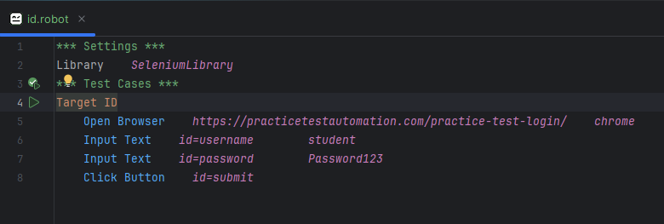

12.2.2 NAME

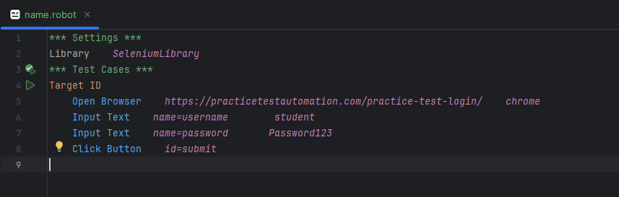

12.2.3 CLASS

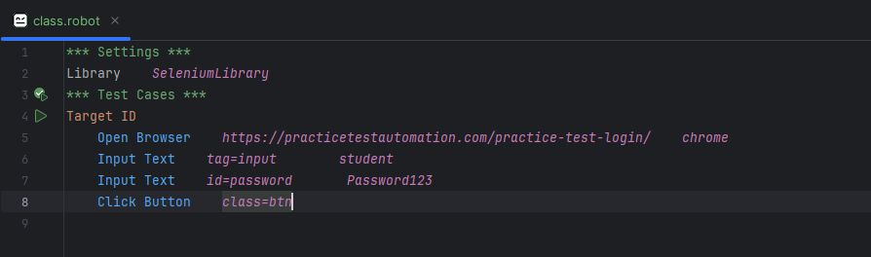

12.2.4 TAG

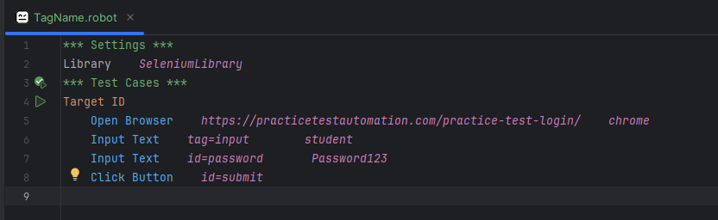

Some Time give one Tag because Give More Tag name it will throw error.

12.2.5 Link Text

For example take Facebook Forgotten Password Link

So It will Target link Text

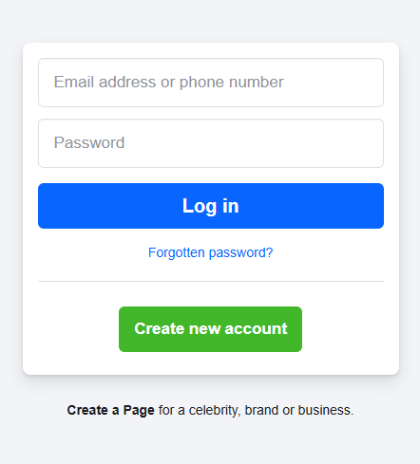

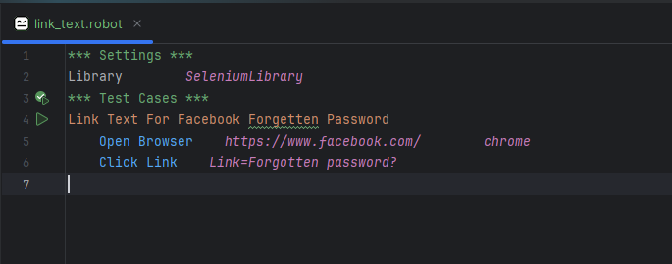

12.2.6 Partial Link

For Example

Link -- forget Password to create New Password

Partial Link - forget

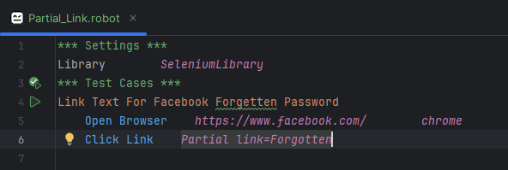

12.2.7 CSS Selector

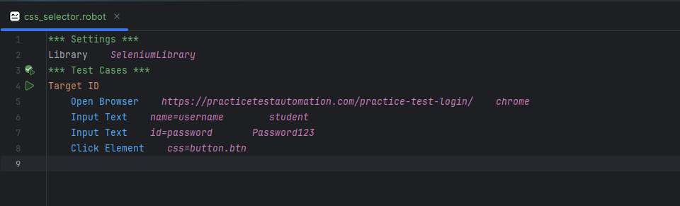

12.2.8 DOM

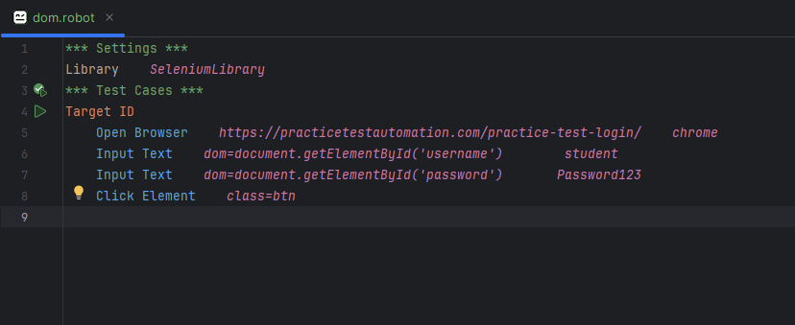

12.2.9 Xpath

Suppose In Website same name or id are repeated.

Xpath value is unique.

**Why use?**

When ID, name, class are not unique or available.

XPath allows for flexible, navigation complex html structures.

Basic Syntax of Path

XPath works like a path in a directory, allowing you to target node in the html Dom.

* //
  + Anywhere in the Document
* /
  + Direct Child
* [@attr=’value’]
  + Match Specific Attribute
* [n]
  + Index (based 0,1)
* Text()
  + Match visible Text

Example with Robot Framework

1. Absolute Xpath

Starts from the root of the HTML document.

2. Relative Xpath (Most used)

Starts with // to search anywhere in the document.

# Input Text xpath=//*[@id="username"] student  
 Input Text *xpath=//input[@id="username"] student*

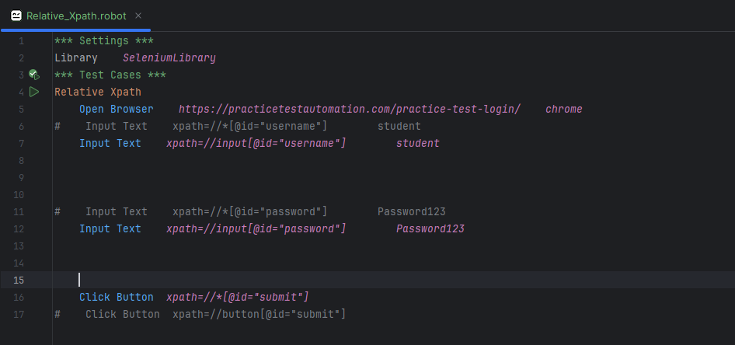

Why use most relative Xpath

Absolute path

Xpath=//div[1]//div[2]//div[3]//div[4]//div[5]

Suppose Developed deleted the div[3]

If delete This code not work that reason only mostly not used

Relative Path

Directly target the element

# Input Text xpath=//*[@id="username"] student  
 Input Text *xpath=//input[@id="username"] student*

Manage the xpath

1. Xpath with @attribute
2. Xpath using and / or
3. Using Contains (Partial match)
4. Xpath by text()
5. Xpath With Indexing

11.2.1.1 Xpath with @attribute

Find element by attribute name and value

Syntax

Click Element xpath = // (Tag name) [@attribute=’value’]

Click Element xpath=//input [@id=’username’]

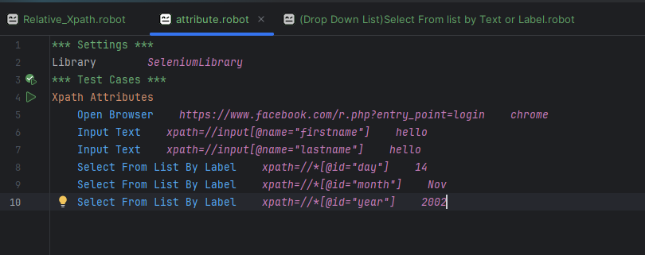

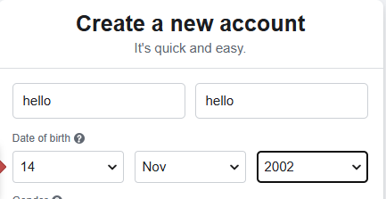

11.2.1.2 Xpath using and / or

Combines multiple attribute checks.

Click Element xpath=//input [@type=’text’ and @name=’username’]

Click Element xpath=//input [@type=’text’ or @name=’username’]

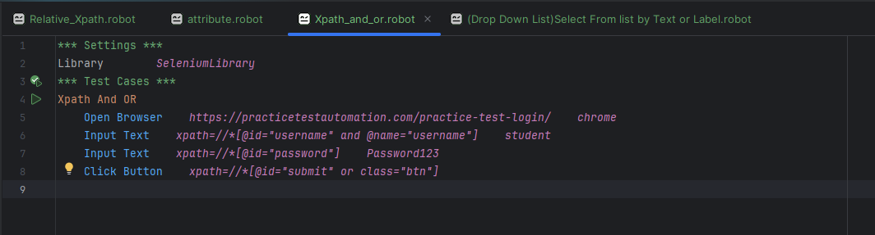

11.2.1.3 Using Contains (Partial match)

Syntax

Click Element xpath=//input [contains (@class, ‘submit’)]

Click Element xpath=//div [contains (text(),’Welcome’)]

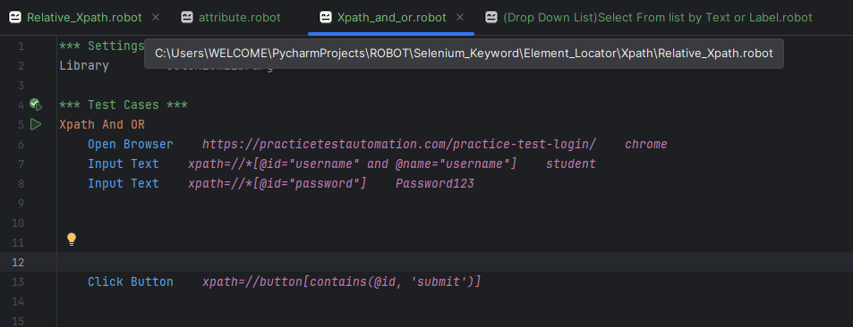

Code

<button class=’btn submitBtn’> submit </button>

11.2.1.4 Xpath by text ()

Matches Element by exact or partial text

For Example

Click Element xpath=//a [text ()=’Logout’]

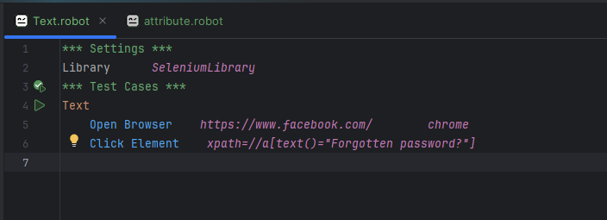

11.2.1.5 Xpath with Indexing

Access a specific element from multiple matches.

For Example

Click Element xpath= (//input[@type=’text’])[2]

# 12.3 Page Interaction Keywords in selenium

Interact with web elements during automation.

1. Click Element

Click on a button, link or any clickable element.

2. Input Text

Enters text into an input field.

3. Select From list by Label / Value

Select an option from a dropdown

4. Get Text

Retrives text content of an element

5. Element Should Be Visible/Present

Validates if an element is visible on the page

6. Wait Until Element is visible

Waits until the element appears (for dynamic content)

7. Execute JavaScript

Runs JS code in the browser context.

8. Switch Window / Frame

Used when a new browser tab or windows opens.

12.3.1 Click Element

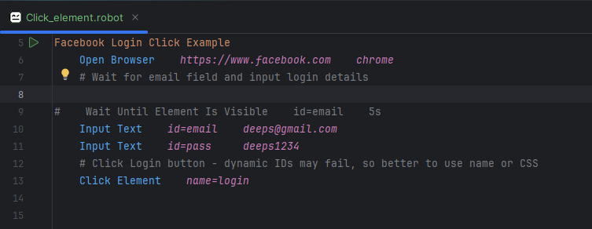

Use id

But use type, class Tag name some error --- (Soon Fix)

12.3.2 Input Text

Input Text {arg1} {arg2}

Locator value

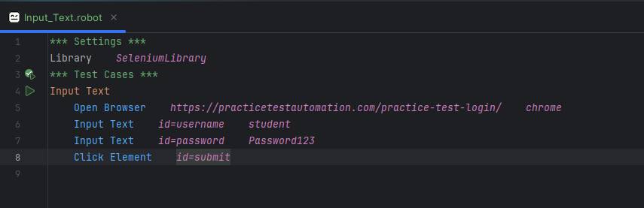

12.3.3 Select From list by Label / Value

These Keyword are used to select an option from a dropdown menu

In html

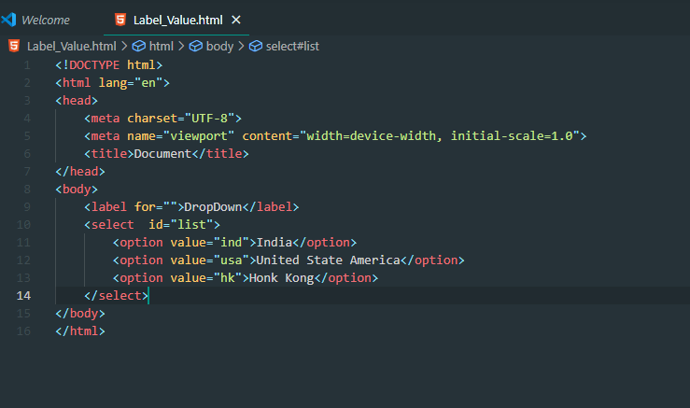

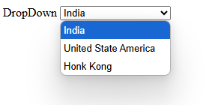

12.3.3.1 Select From List By Label

Selects Option using visible test or label.

Syntax

Select From List By Label locator visible_text

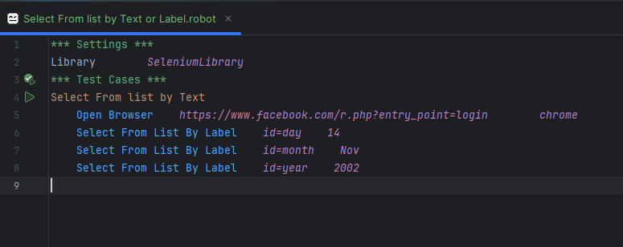

Facebook create account page

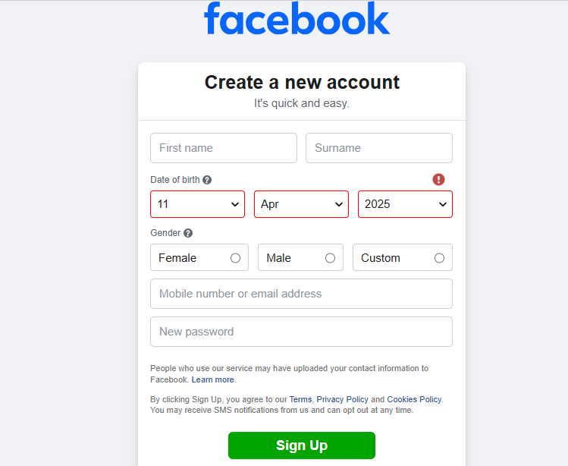

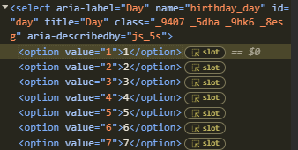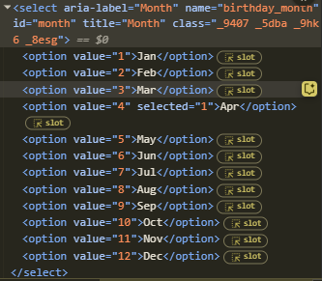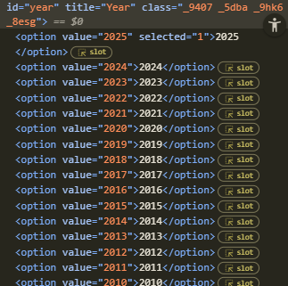

12.3.3.2 Select From List By Value

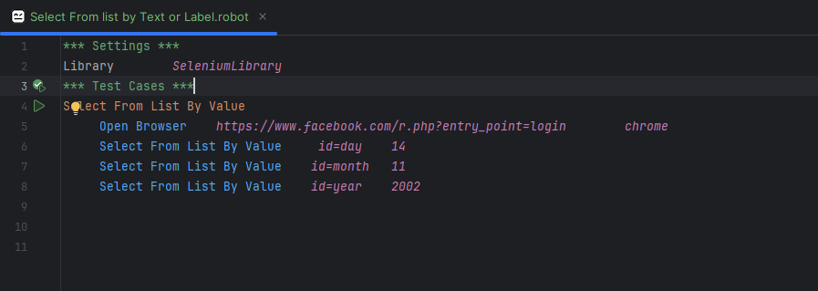

12.3.4 Get Text

Get Text gets the visible text content

Syntax

${variable}= Get Text locator

Locator—id,xpath,css etc

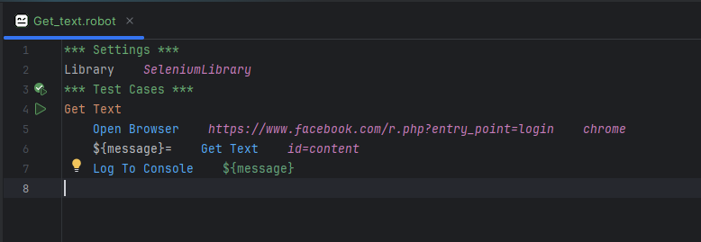

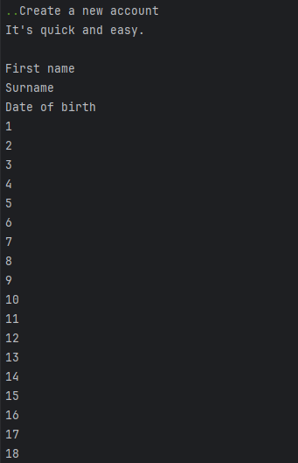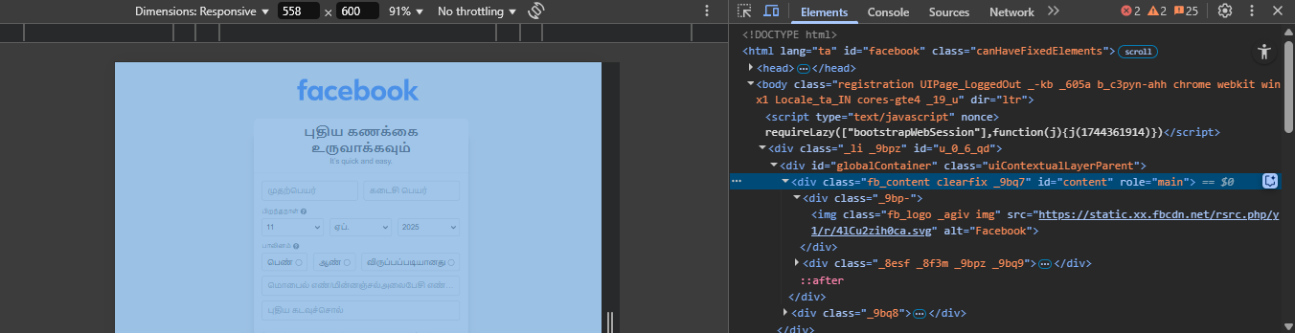

# Task1

Place holder name take and store in variable and name used in Two input box

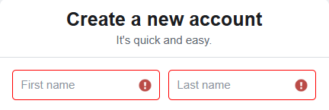

12.3.5 Element Should Be Visible--- Present or not

Checks if the element I visible or not.

Syntax

Element Should Be Visible locator

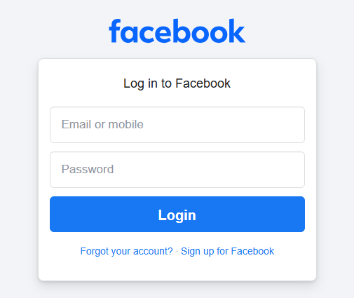

Take the value **Log in to Facebook**

**Inside the value in Email Box and Password box**

**>>>>>>>>>>>>Email: Log in to Facebook**

**>>>>>>>>>>>>Password: Log in to Facebook**

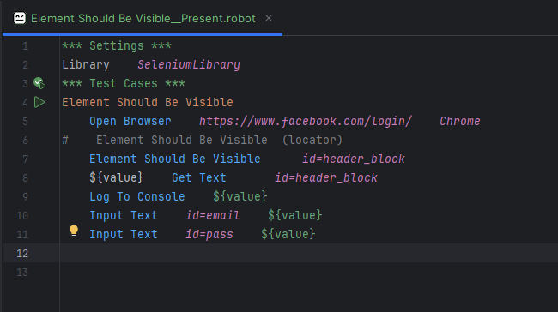

12.3.6 Wait Until Element is visible

It is visible on the webpage

Syntax

Wait until Element Is Visible Locator timeout

12.3.6.1 Normal Program Open and Close

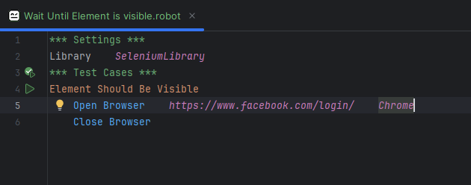

This Path will show error because locator use id, class,css not used in browser link

⚠️ERROR

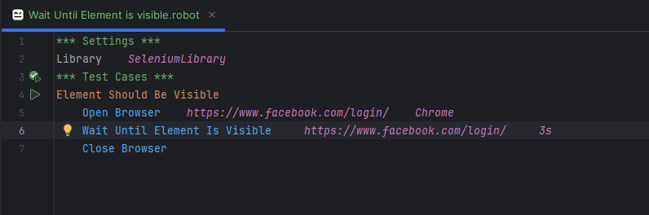

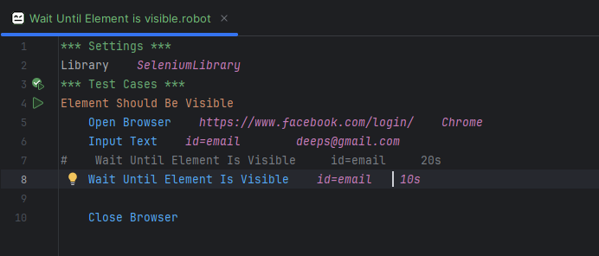

12.3.7 Execute JavaScript

It runs Raw JavaScript code inside the browser session.

• Click hidden/disabled elements

• Scroll elements into view

• Change styles or values

• Trigger JavaScript functions

* Scroll Element into view

For Example 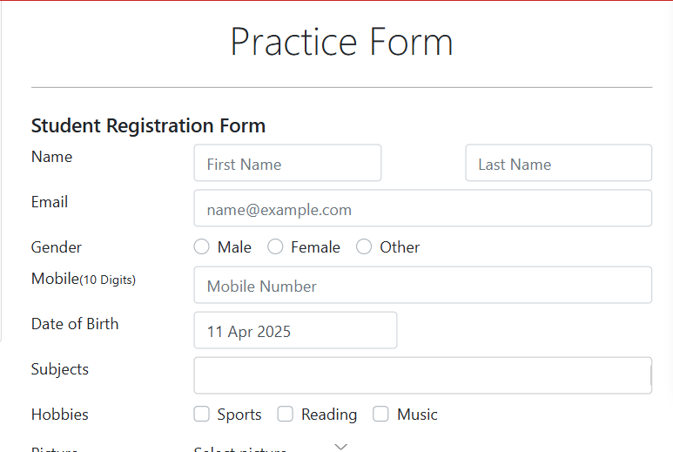

Scroll the page get submit button.

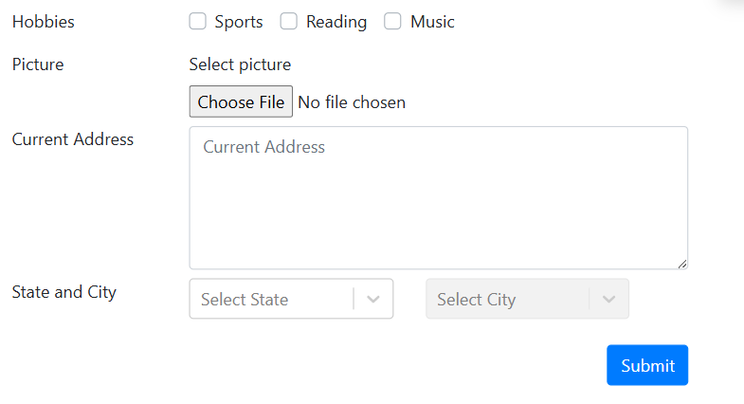

We take only test username and password.

But submit locate in last.

We use JavaScript to target the element easy.

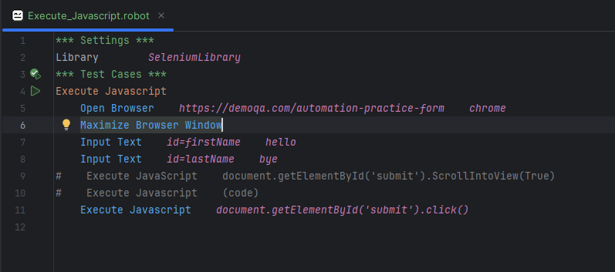

12.3.8 Switch Window / Frame

Switch Window

Switches from the current browser window/tab to another popup windows or new tab.

Why it’s needed:

When clicking a link opens a new tab or windows, Selenium can’t interact with it unless you switch to it.

Syntax

Switch Window Locator or Browser

Locator

* Title = Window title
* Url=https://www.googlee.com
* NEW = switch to the newest window
* MAIN = switch back to the main window

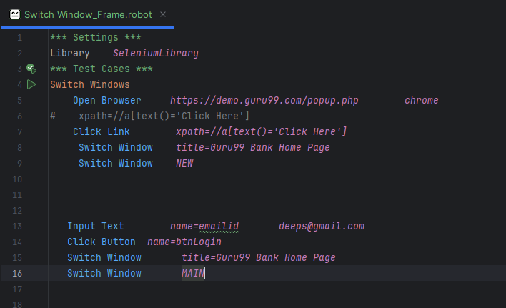

Output---

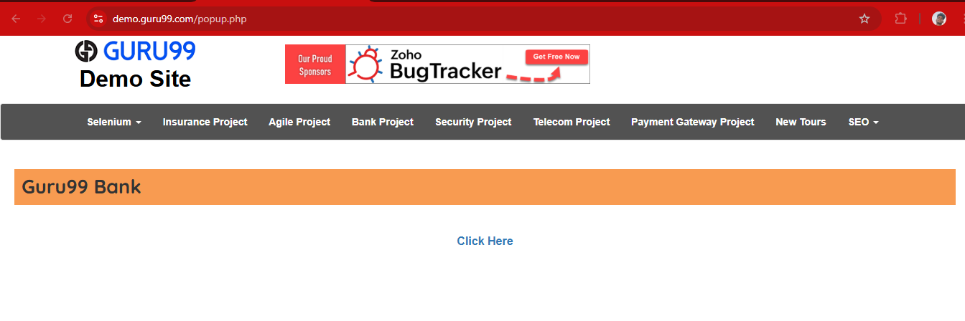

----------------------------------------------------------------------------------------------------------------------------------------------------------------------------------------------------------------------------------------------------------------------------

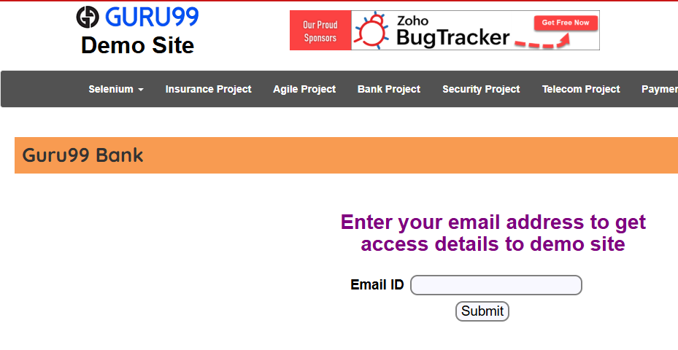

----------------------------------------------------------------------------------------------------------------------------------------------------------------------------------------------------------------------------------------------------------------------------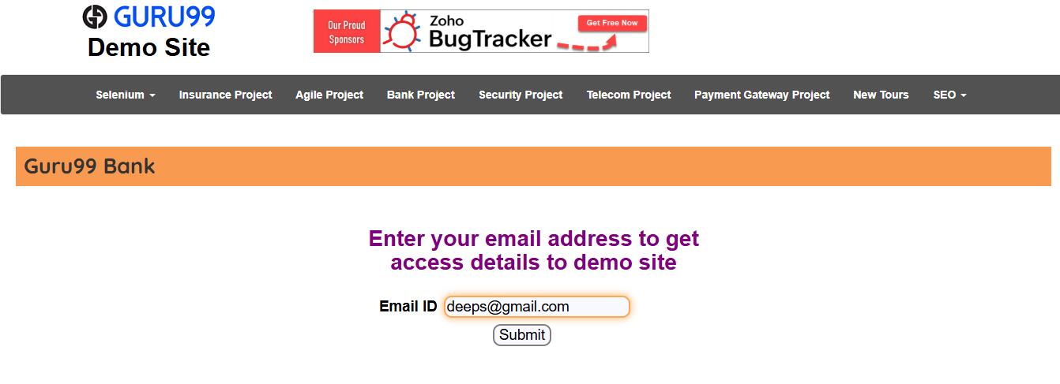---------------------------------------------------------------------------------------------------------------------------------------------------------------------------------------------------------------------------------------------------------------------------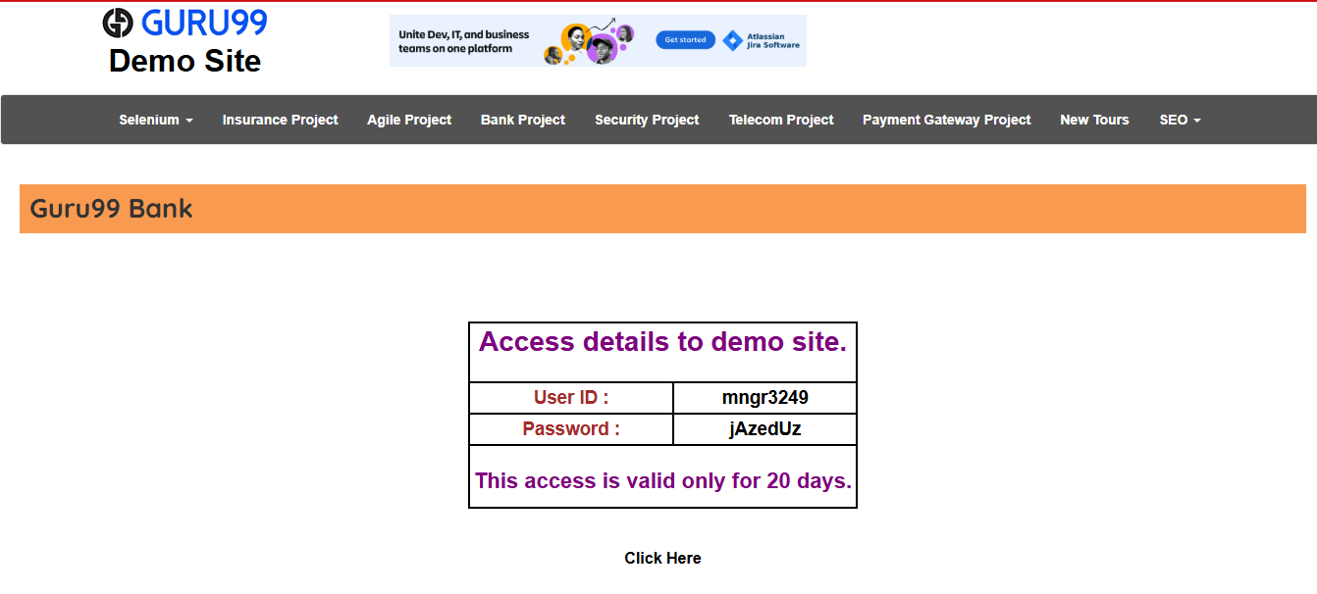

----------------------------------------------------------------------------------------------------------------------------------------------------------------------------------------------------------------------------------------------------------------------------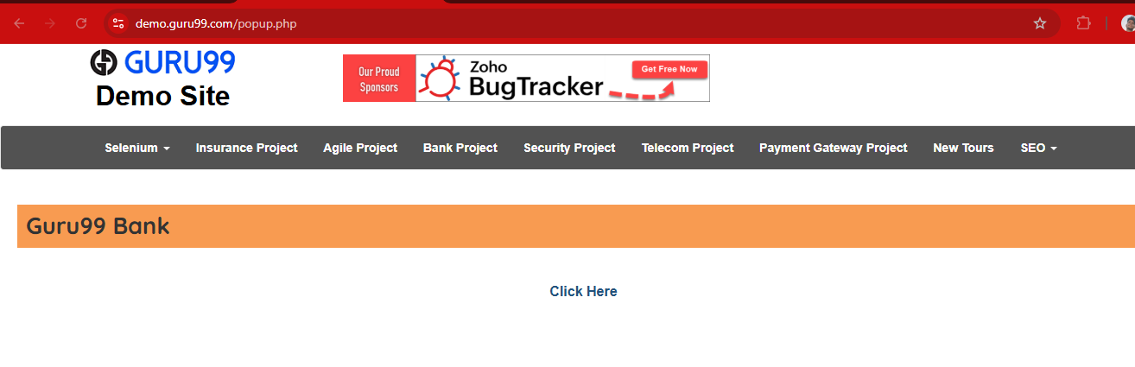

-------------------------------------------------------------------------------------------------------------------------------------

12.3.8.2 Switch Frame

It like a webpage inside a webpage

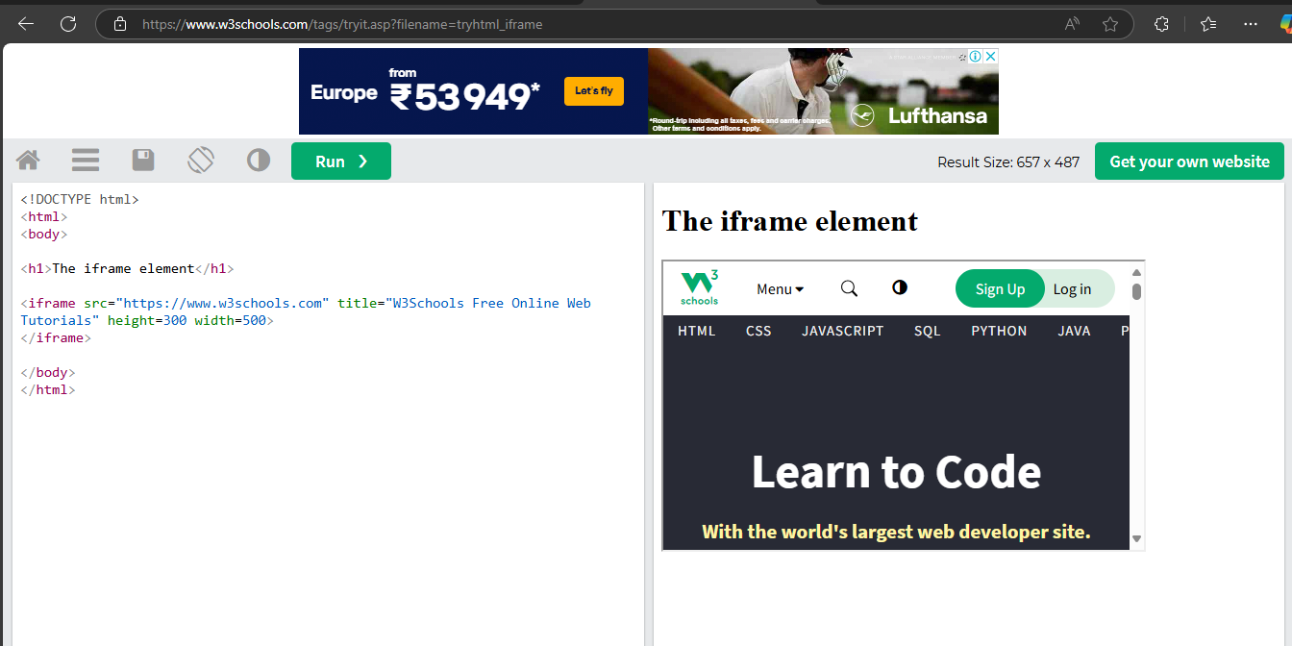

Why use Switch Frame?

You must use Switch Frame

The element you want to interact with is inside an iframe.

Use

Switch Frame Locator

Example

By using index

Switch Frame index=0

By using name or id

Switch Frame myFrame

By using Xpath

Unselect Frame

You can out of the iFrame and back to the main content

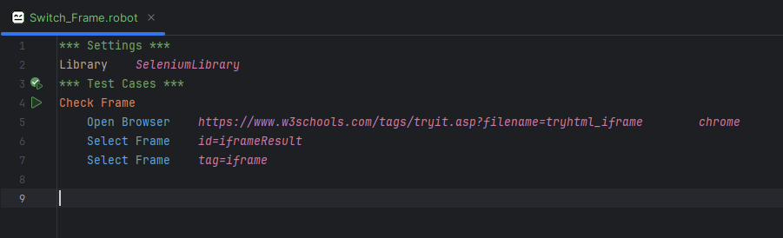

# 12.4 **Waits & Timings in Robot Framework**

**SeleniumLibrary has built in waiting mechanisms to handle timing issues. You can either explicitly wait for element or set default timeouts.**

**12.4.1 Set a Default timeout (applies to all keywords)**

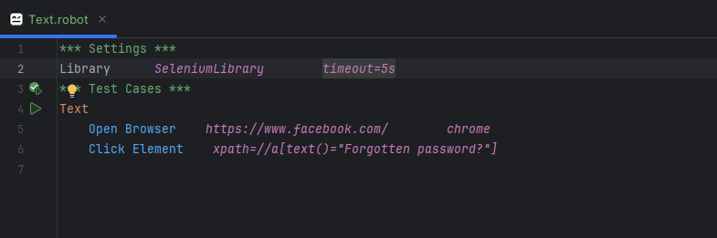

**11.4.2 Sleep**

**It is used to just or stop the page**

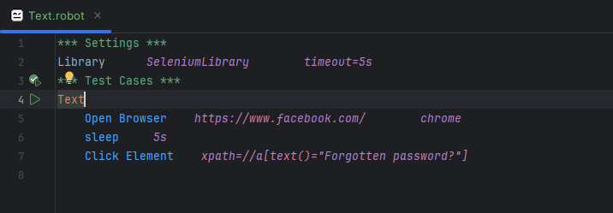

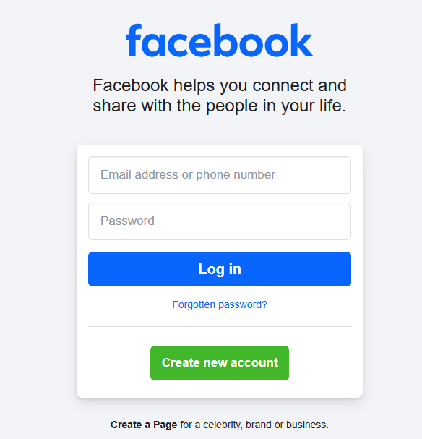

**This page wait 5s after click the Forgotten Password?**

# 12.5 Box

**To handle dropdowns, radio button (like Gender Boxes), and other advances input field using Robot Framework with seleniumLibrary.**

12.5.1. Dropdown (Select Box)

To interact with dropdowns

### ✅ Keywords:

* Select From List By Label
* Select From List By Value
* Select From List By Index

12.5.1.1 Select From list By Label

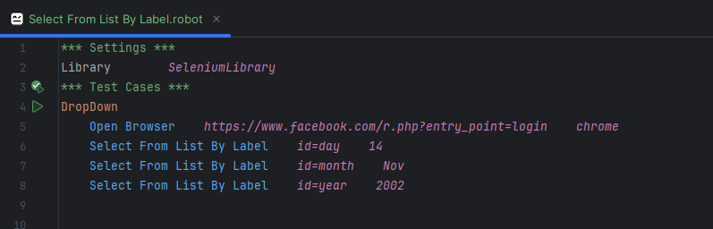

12.5.1.2 Select From list By Value

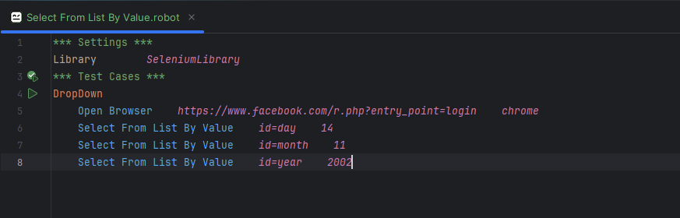

12.5.1.3 Select From list By Index

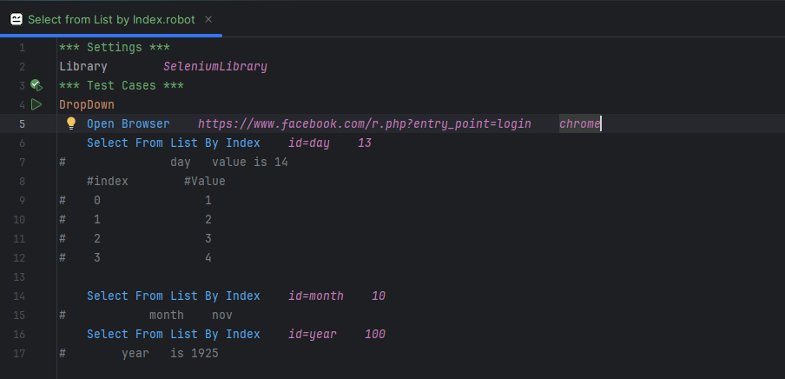

12.5.2 Gender Box (Radio Button)

Radio buttons are selected with Click Element or Select Radio Button

12.5.2.1 Select Radio Button (preferred for group name & value)

Syntax

Select Radio Button *(group_name, value)*

Html Page Console

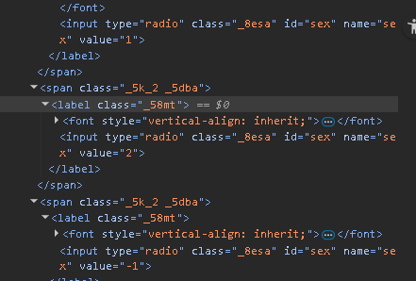

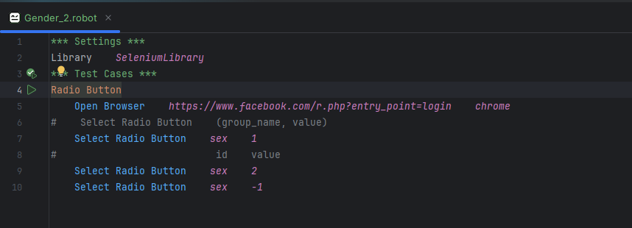

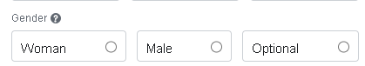

#1 #2 #-1

12.5.2.2 Click Element (useful if XPath is more specific)

Syntax

Click element Locator

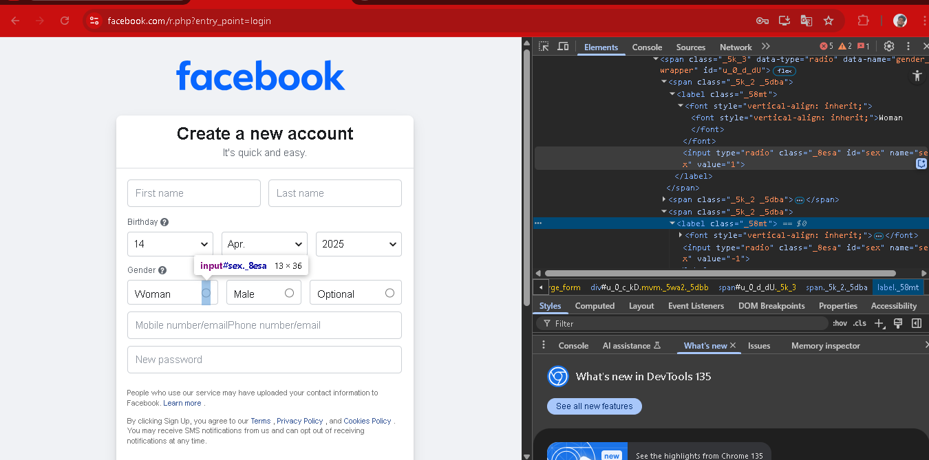

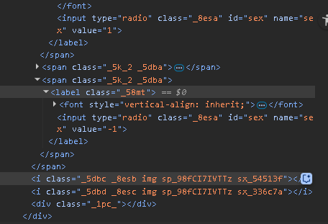

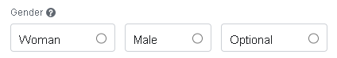

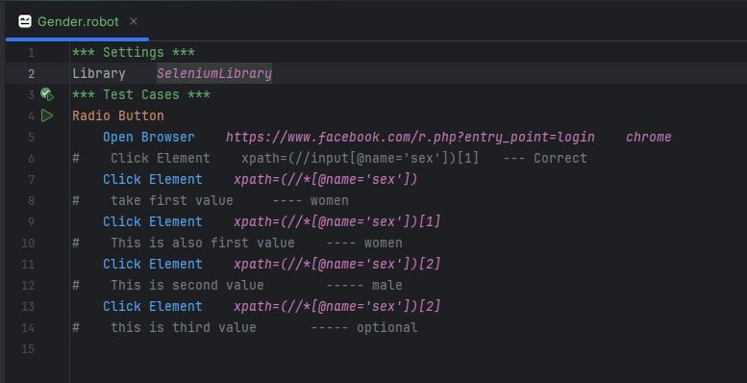

12.5.3 Check Boxes

Checkboxes can be checked or unchecked

Syntax

Select Checkbox *Locator*Unselect Checkbox *Locator*

Or

Click Element Locator

12.5.3.1 Select Checkbox

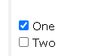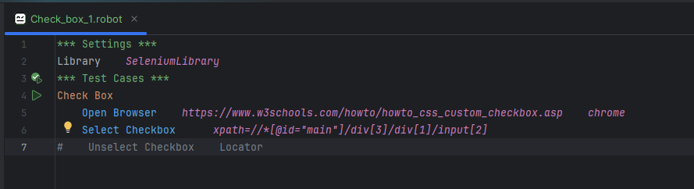

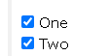

Or

Click Element

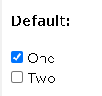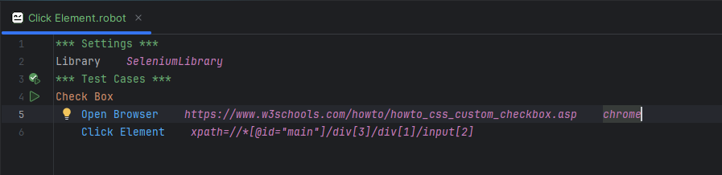

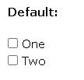

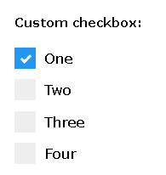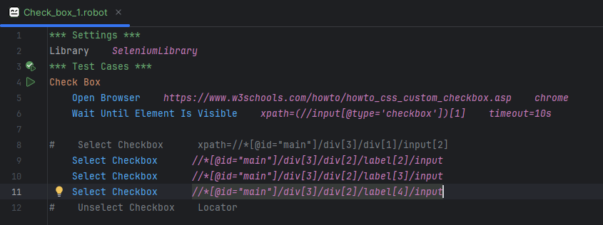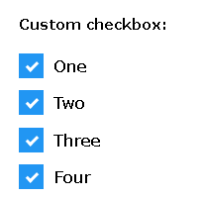

12.5.3.2 Unselect Checkbox

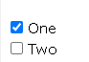

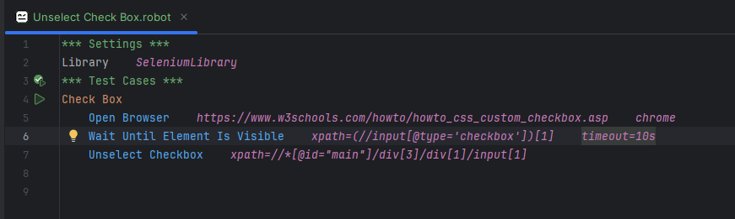

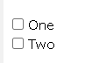

12.5.4 Custom / JavaScript-driven Inputs (Advanced Boxes)

Sometimes dropdown, slider or search boxes are made with JavaScript libraries.

• Click to open dropdown

• Use XPath to select option

Click Element xpath=//div [@class='custom-dropdown']

Click Element xpath=//div [contains (text(),'India')]

**\*\*\* Settings \*\*\***

**Library SeleniumLibrary**

**\*\*\* Test Cases \*\*\***

**Fill Registration Form**

**Open Browser https://example.com/register chrome**

**Input Text name=first_name John**

**Input Text name=last_name Doe**

**# Select Gender**

**Select Radio Button gender male**

**# Select Country from dropdown**

**Select From List By Label id=country India**

**# Subscribe to newsletter (checkbox)**

**Select Checkbox id=newsletter**

**# advanced custom dropdown (click + select)**

**Click Element xpath=//div [@class='dropdown-toggle']**

**Click Element xpath=//li [text ()='Option 1']**

**Click Button id=submit**

# 12.6 Alert Boxes

**Handle alert Boxes using the seleniumLibrary**

| **Keyword** | **Description** |
| --- | --- |
| Alert Should Be Present | Verifies if an alert is present |
| Get Alert Message | Gets the alert's message |
| Handle Alert | Accepts or dismisses the alert (ACCEPT/DISMISS) |

**12.6.1** Alert Should Be Present

12.6.1.1 Alert Box (alert())

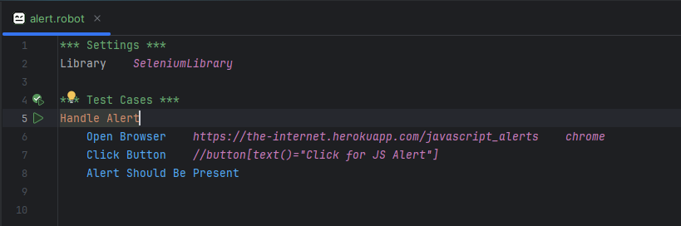

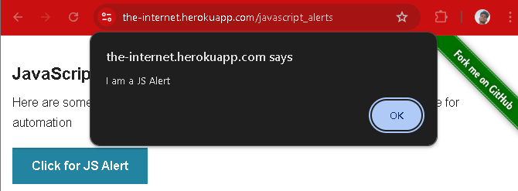

12.6.2 Get Alert Message

(Code)

12.6.3 Handle alert or Dismiss Alert

(Code)

# 13. Selenium Keyword vs Custom Keyword

# 13.1 Selenium Keyword

There are predefined keywords provided by the SeleniumLibrary, used for automating web browsers.

Keyword Like

* + Open Browser
  + Click Element
  + Input Text
  + Wait Until Element Is Visible
  + Close Browser

# 13.2 Custom Keywords

These are user-defined keywords where you define a sequence of steps to make tests more readable and reusable.

Features

* Created by you
* Can Contain Selenium Keyword or any other keyword
* Reuse , modularity and clarity

Example

*** Settings ***

Library SeleniumLibrary

*** Keywords ***

Login To Website

Open Browser https://example.com chrome

Input Text id=username myuser

Input Text id=password mypass

Click Button id=login

*** Test Cases ***

Test Login Flow

Login To Website

Page Should Contain

# 14. Normal Part of the Robot Framework settings.

1. Documentation

Describes what the test suite, test case or Keyword.

Why use

For Clarity, collaboration and visible documentation in test reports.

2. Test Setup

Runs a Keyword before each tests case in the suite.

Or

Set of instructions that will run before each test case.

Why use

To set up preconditions like opening a browser, logging in, etc.

3. Test Teardown

Runs a keyword after each test case in the suite.

Why use

For clean-up tasks like closing the browser, logging out, etc.

4. Suite Setup

Runs once before all tests in the suite.

Why use

To perform actions like initializing database or starting services.

5. Suite Teardown

Runs once after all test in the suite.

Why use

To stop service, close connections, generate final reports, etc.

6. Test Timeout

Sets a time limit for how long a test case can run.

Why use

To avoid infinite waits or hanging tests.

7. Default Tags

Applies default tags to all test cases.

Why use

For organizing, filtering or selecting tests during execution.

8. Test Tags

Assigns specific tags to one test case.

Why use

To group or identify specific tests

9. Keyword Tags

Tags user-defined keywords

Why use

Helps with test documentation and filtering

10. Test Template

Used for data-driven testing runs the same test with different data.

Why use

Reduces duplicate code

**14.1 Documentation**

The Documentation setting in Robot Framework is used to describe the purpose of Test suites and Test cases.

This helps teams understand what the automation is doing, why and something.

13.1.1 with using Documentation

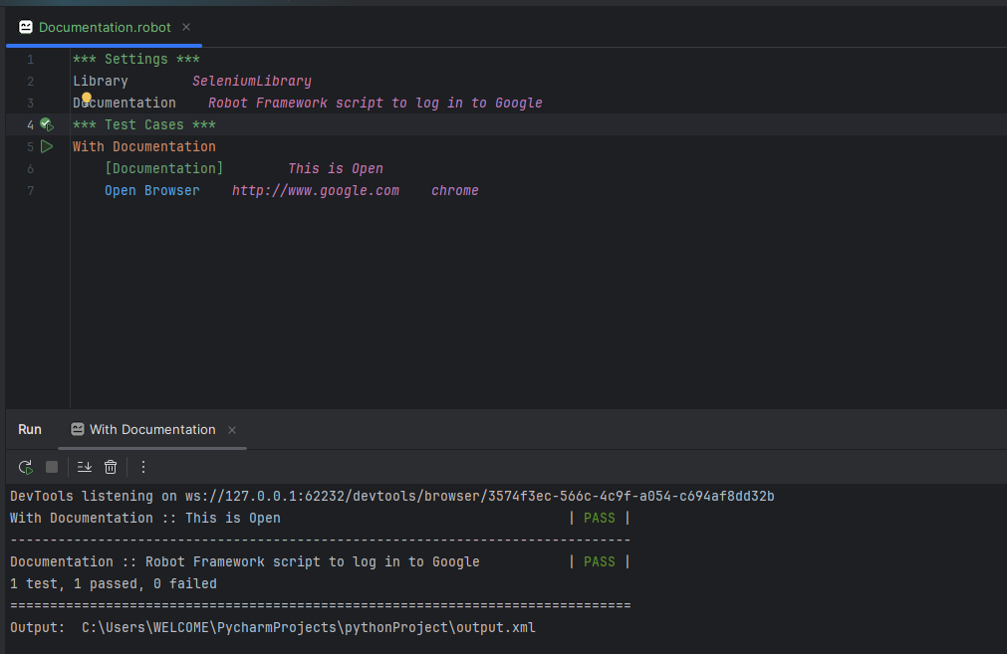

14.1.2 without using Documentation 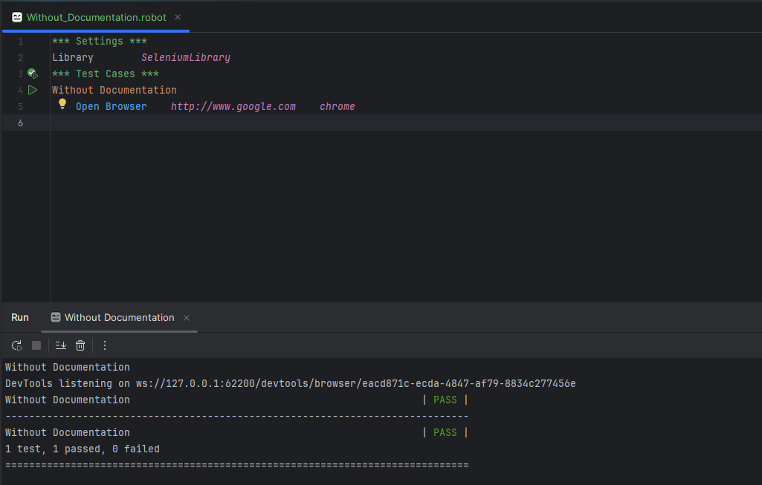

Real Example for Documentation

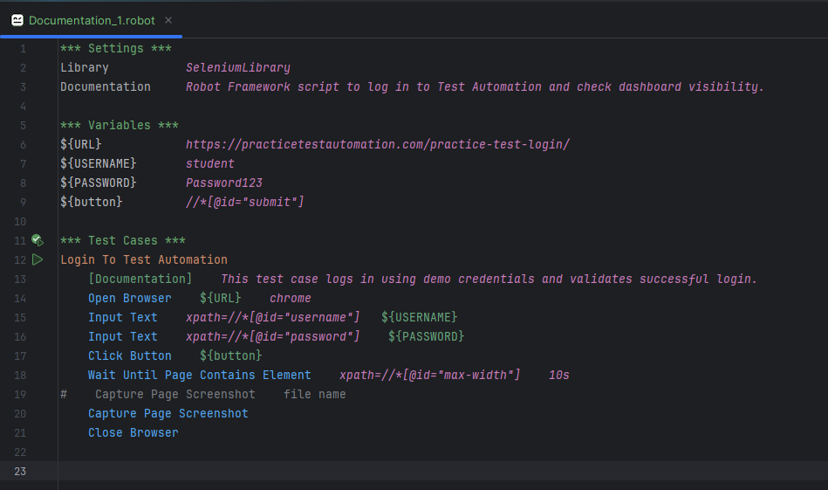

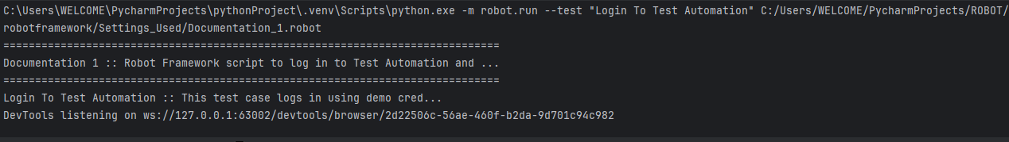

Without using documentation

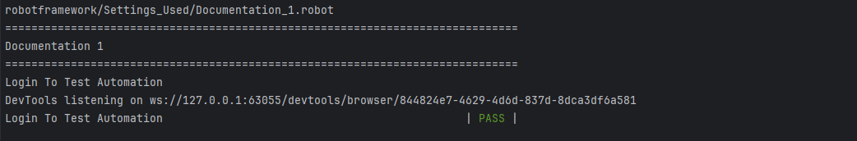

14.2 Test Setup

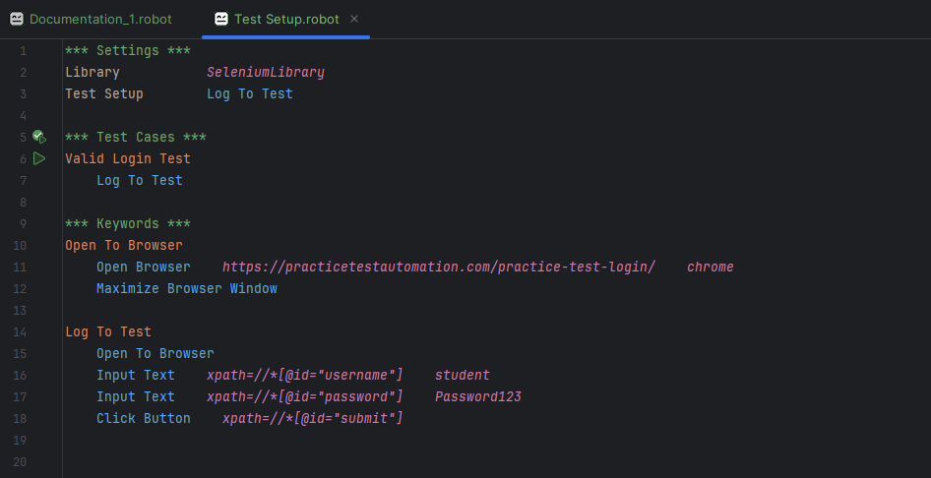

Run on two times

14.3 Test Teardown

# 15. Testing

* Acceptance testing
* Keyword-Driven Testing (KDT)

# **15.1 Acceptance Testing**

Acceptance Testing is a type of testing performed to determine if the system meets the business requirements and is ready for delivery. It’s the final step before the software goes live.

Or

Acceptance Testing is the final level of software testing. It ensures the system behaves as expected from the user or business perspective, validating it against the requirements or use cases.

Think of it as: “Does this application do what the client/stakeholder asked for? “

**Why Use Robot Framework for Acceptance Testing?**

* It uses plain English like Syntax.
* It support data-driven, behaviour-driven and keyword-driven testing.
* Work well with libraries like SeleniumLibrary, RequestsLibrary and DatabaseLibrary.
* Easy to integrate with CI/CD tools like GitHub action.

How Acceptance Testing Works in Robot Framework

1. Define User Stories/Requirements

* E.g., “As a user , I want to log in to view my dashboard. ”

2. Write Test Cases in Robot Framework

* Convert user story into steps using keywords

3. Use Relevant Libraries

* Like SeleniumLibrary , RequestsLibrary etc.

4. Execute Tests

* Run .robot files using robot command

5. Review Reports

* Robot auto-generates a report.html and log.html

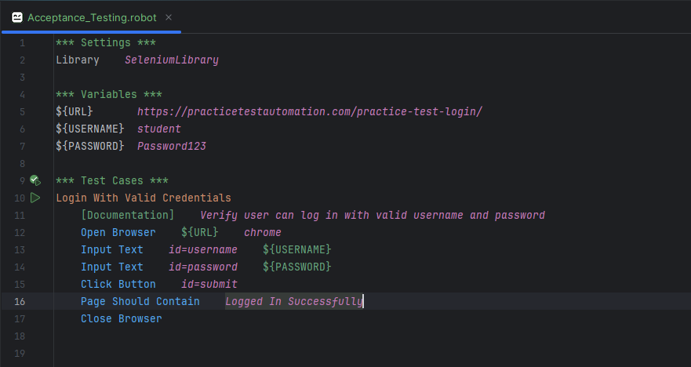

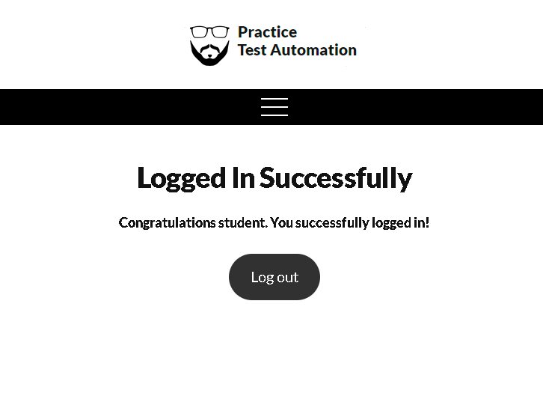

Summary

* Robot Framework is a perfect tool for Acceptance Testing.
* Easy for technical and non-technical
  + Technical -- Developer , Team Lead etc.…(Easy to understand the code)
  + Non –Technical – QA analysts, product owners, or clients can understand the steps without knowing programming.
  + Robot Framework automates saving time and effort, especially for regression testing before each release.

Why time save

Imagine you’re testing a login page. You have 50 test cases to check different browser(Chrome,firefox,opera) , user roles , and different devices (android , iOS).

Doing this manually for take some days. With Robot Framework done in minutes with logs, reports and screenshot.

* Boosts quality, Build confidence, Improve Traceability in your release process.
  + Boost quality

Reduced human error

* + - * Automated acceptance tests are consists unlike manual testing.
  + Build confidence

Pass / fail

* + - * You get immediate feedback.
      * Code Pass or Fail
  + Improve Traceability

Logs and Reports

* Robot gives detailed logs with steps , screenshot and help to trace failures and debug easily.

# 14.2 Keyword-Driven Testing (KDT)

1. Keyword-driven testing is a test automation approach where tests are written using high level keywords each representing specific action or set of actions.

* Test Automation approach
  + KDT method used in automation testing
  + KDT is not a tool, but a way of designing your automated tests --- a strategy to make writing tests easier and more organized.
* High – level keywords
  + Instead of writing complex code (like in python or java), you write your test steps using simple , understand commands (called Keywords)

Example

Demo.test

Login To Application

Click Button submit

These are high-level because they describe what to do, not how it’s done.

* Specific action or set of actions.
  + Each Keyword (like Login To Application) stands for a single actions (like clicking a button) or a group of actions (like opening a browser, typing username/password, and clicking submit)
* Example

*** Keywords ***

Login To Application

Input Text username user1

Input Text password pass1

Click Button login

Here, Login To Application is a custom keyword that performs multiple actions.

2. Instead of writing complex code, you write test steps in a natural-language style using reusable keywords.

What it means: (without using Library)

In Traditional test automation (like using python or java), testers often need to write a lot of programming code

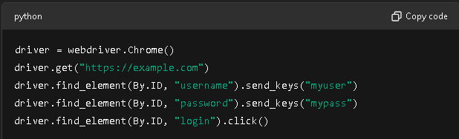

What it means (with using Library)

With Robot framework,you write test steps in a simple , readable format , similar to plain English.

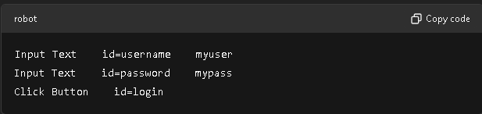

3. It separates test logic (what you’re testing) from the test implementation (how it’s tested)

1.Test Logic – What you’re Testing

Example of test logic:

* Verify that a user can log in successfully.
* Check that the dashboard displays after login.
* Ensure that a user gets an error for wrong password.

In Keyword-driven testing,your test cases clearly show what is being tested without technical complexity.

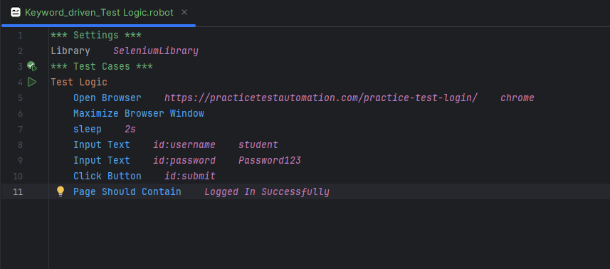

This way also run the code (:)

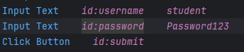

2.”Test Implementation” -- How it’s Tested

This refers to the technical steps and code that actually perform the actions (Clicking button, filling field etc., submit button)

In Robot Framework

Robot Framework is built around at keyword-driven concept. You write tests using predefined keywords from libraries (like SeleniumLibrary) or your own custom keywords.

|  |  |
| --- | --- |
| Acceptance Testing | Keyword – Driven Testing |
| Testing that verifies whether the end-to-end functionality of a system meets business requiremnts or user needs.It validates the “What” ---- i.e., is the system working correctly from the user’s point of view? | A test design approach where tests are written using high-level keywords , each representing specific actions.It’s focused on the “How” – i.e., how the test logic is implemented in a reusable and readable way. |

|  |  |  |
| --- | --- | --- |
| Features | Acceptance Testing | Keyword-Driven Testing |
| Purpose | Verify business / user requirements | Structure and organize test implementation |
| Focus | What the system should do | How to perform the test steps |
| Who uses it | Business analysts,testers,stakeholders | Test automation engineers , QA team |
| Example | Test login features,shopping cart,checkout | Define “Login To Application” keyword to reuse in tests. |
| Test style | High-level scenario-based | Logic-structured,modular style |

Which is used More and Why ?

Keyword-Driven Testing is used more in practice

Because

* Robort framework I build on keywords
* Even acceptance tests are written using keywords.
* Keywords enable reusability, scalability and modularity.

Acceptance Testing

|  |  |
| --- | --- |
| Advantages | Disadvantages |
| Validates user / business needs | Often high-level, misses internal issues |
| Helps catch UI and functional errors  (See the error easily find the login page  For eg Name: text box not set it replace ratio box. Now easily find the error) | Can be time consuming manually |
| Easy for stakeholders to understand | Needs stable system for testing |

Keyword-Driven Testing

|  |  |
| --- | --- |
| Advantages | Disadvantages |
| Reusable and modular | May get complex with too many keywords |
| Low code style | May hide internal logic |
| Allow non-programmers to contribute | Test failers can be hard to trace without logs |

## 🧠 Summary

| **Feature** | **Acceptance Testing** | **Keyword-Driven Testing** |
| --- | --- | --- |
| Goal | Validate business functionality | Structure reusable test steps |
| Works in Robot Framework? | Yes | Core feature |
| Best used for | High-level test cases | Test implementation |
| Most used? | Less frequent | **Always used** (every test uses keywords) |

# 14.3 Data –Driven Testing (DDT)

# 14.4 Behaviour Driven Testing(BDT)

# 14.5 Robotic Process Automation(RPA)

# 15. Advance Topic

# 15.1 How to add any id, class.

For Example

In Flipcart application Login Button

<span>Login</span>

This xpath=

Click Element *xpath=//*[@id="container"]/div/div[1]/div/div/div/div/div/div/div/div/div[1]/div[1]/header/div[2]/div[2]/div/div/div/div*

In Robot framework Target

1.

//span[text()='Login']

2.

//span[normalize-space(text())='Login']

Case-1 Normal Click Button or Element

Span Tab is Element

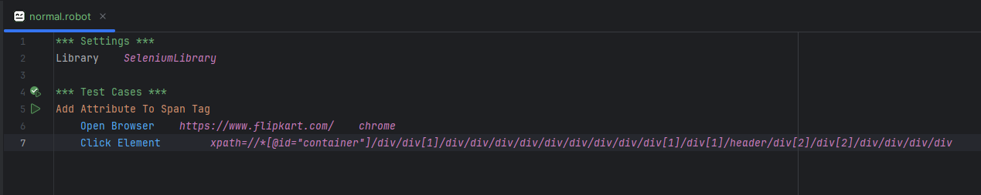

Case-2 Add Id in Login Button using Execute Javascript

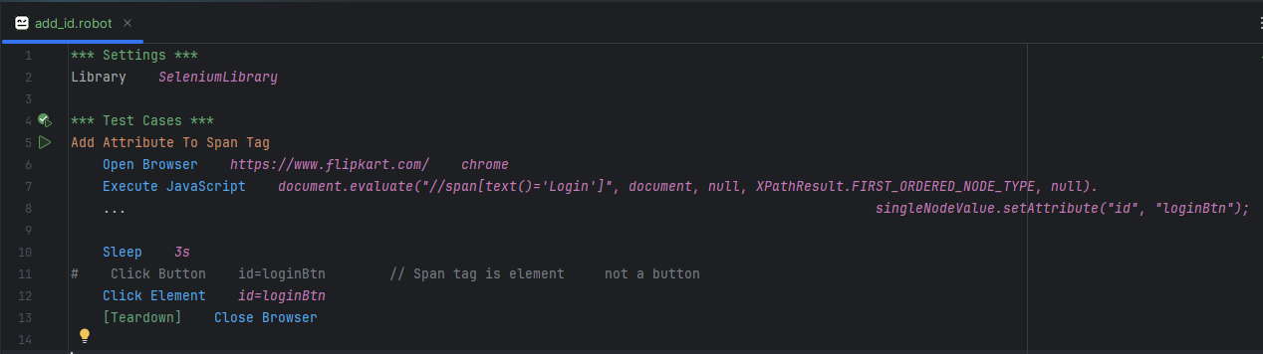

Case-2 Add Class in Login Button using Execute Javascript

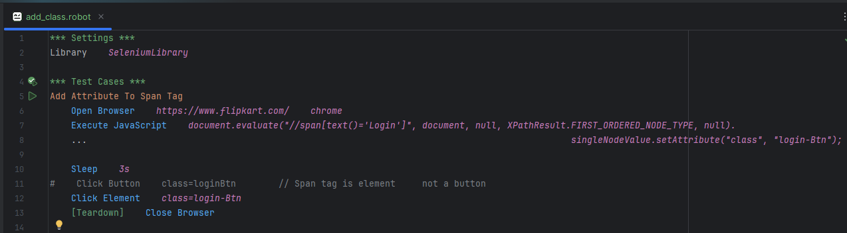

Execute Javascript

document.evaluate("//span[text()='Login']", document, null, XPathResult.FIRST_ORDERED_NODE_TYPE, null).singleNodeValue.setAttribute("id", "loginBtn");

Breakdown of Each Steps

1. Document. Evaluate (…)

This method is used to evaluate an xpath expression on the document (i.e., the HTML content of the webpage). It searches for nodes that match the given Xpath.

2. **"//span[text()='Login']"**:

This is the Xpath expression that searches for a <span> element that contains the exact text “Login”.

//span looks for any <span> element and [text()=’Login’] filters those that have the exact text “Login”.

3. Document

The document object refers to the entire HTML element content of the webpage currently loaded in the browser.

The DOM (Document Object Model) allow you to interact with the page elements (like paragraph, images, button, etc.) using Javascript.

4. Null

This represents the namespace resolver, which is not needed here because the Xpath expression doesn’t require any namespaces.

5. **XPathResult.FIRST_ORDERED_NODE_TYPE**:

This specific the type of result we are expecting from the xpath evaluation.In this case,we want the first matching node (in this case,the first <span> with “Login”)

6. null (again)

This is the result of the evaluation, used to specific any custom filtering of nodes.

Here, it’s just null meaning we are simply looking for the first match.

7. single Attribute (“id”, “loginBtn”)

This property retrives the first matching node from the result the Xpth evaluation. It’s essentially the <span> element you found using the Xpath

8. SetAttribute ("id", "loginBtn")

This method adds an id attribute with the value “loginBtn” to the <span> element

# 16. File Handling

File handling in robot framework refers to the ability to create, read, write, modify, delete, and manage files and directories during test automation.

This allows automated scripts to interact with the file system.

Why Use File Handling in Robot Framework?

1. Log Verification

Check if expected logs are written

2. Data-driven testing

Read test data from files

3. Configuration updates

Write or modify config files.

4. Cleanup

Delete or archive files after testing.

Tools/Libraries used in robot framework for file handing.

| **Library** | **Purpose** |
| --- | --- |
| OperatingSystem | Core file/directory operations (create, delete, move, etc.) |
| BuiltIn | Basic variable handling and string manipulation |
| Collections | Useful for list processing (when dealing with file lines) |
| String | Helps with file content formatting or checks |

Common File Operation in Robot Framework

1. Create File

Create a file

2. Append To file

Append to file

3. Get File

Read entire file

4. Get File Lines

Read file lines

5. File Should Exist and Folder Should Exixt

Check file present or not

6. Remove File

Delete a file

7. Modifying a File (Read, Modify, Write Back)

8. Copy File, Move File

Copy / Move / Rename file

9. Create Directory, Remove Directory

Create / Delete directory

Example

1. Create a file

Syntax

Create File *Path Content*

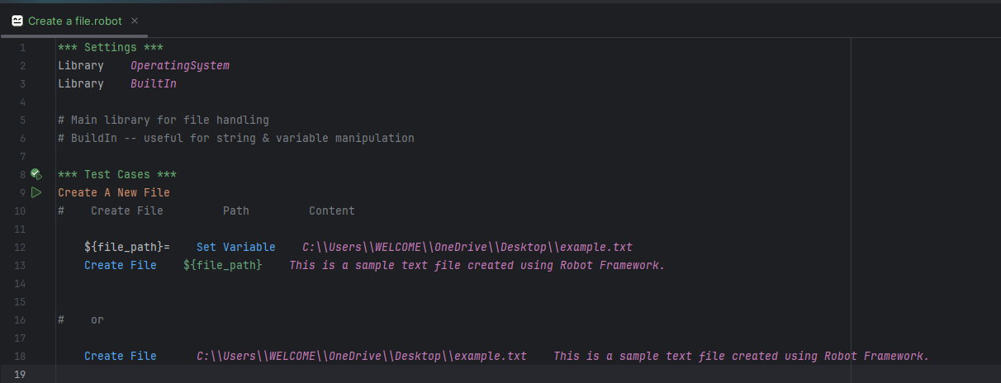

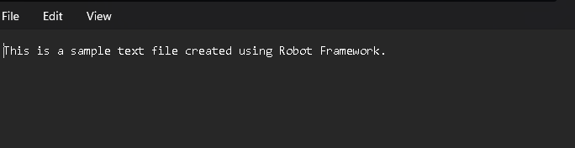

1.1 Folder

Syntax

Create Directory *path*

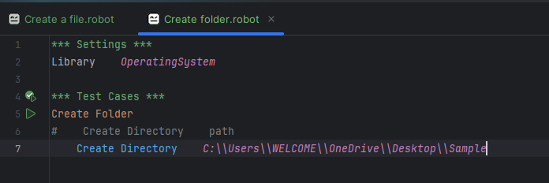

2. Append To File

Syntax

Append To File path content

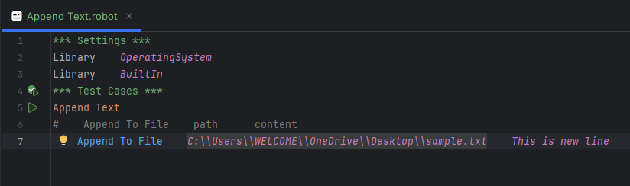



3. Get File

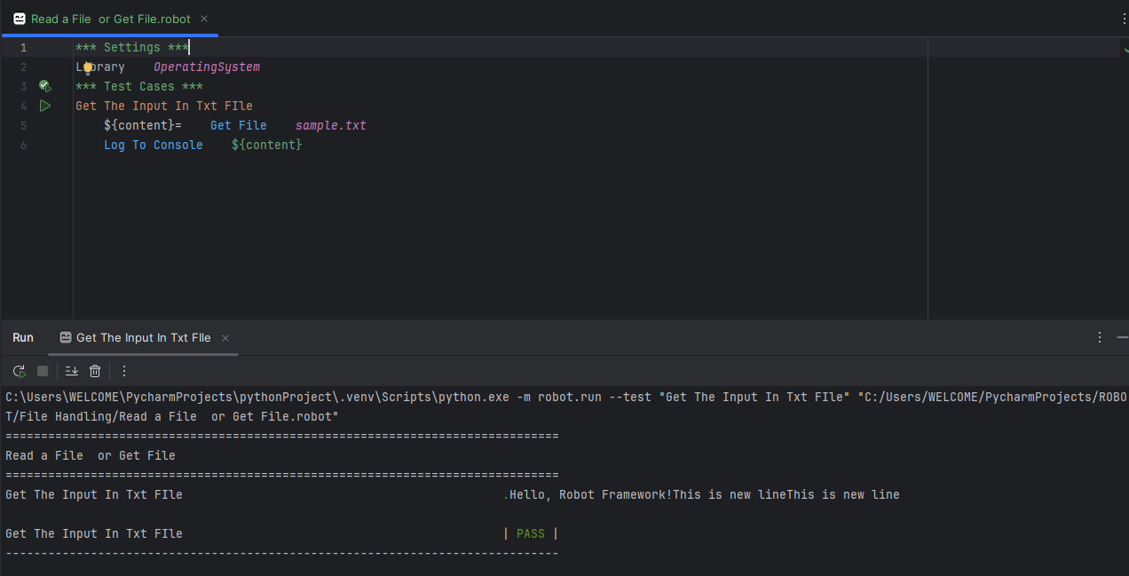

4. Get File Lines

Some Error

5. File Should Exists

Syntax

File Should Exist *path*

5.1 Folder Should Exists

Syntax

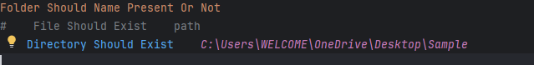

Use C:\\Users\\WECOME\\OneDrive\\......

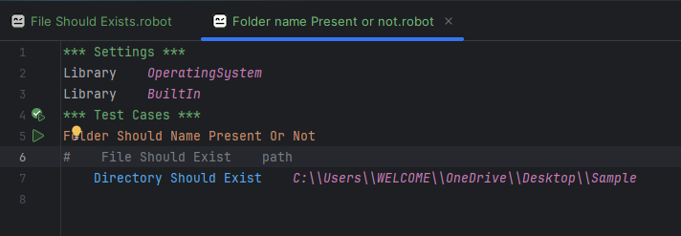

6. Delete a File

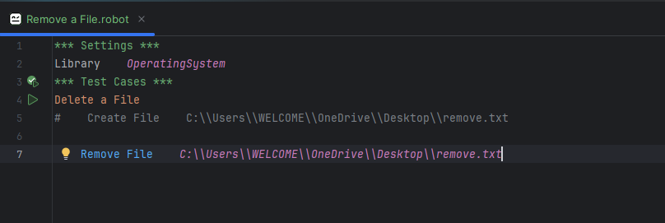

7. Modifying a File (Read, Modify, Write Back)

7.1 Read the file

7.2 Modify the file

8. Copy File, Move File

## 🔁 10. **Copy/Move/Rename Files**

### Copy File:

robot

CopyEdit

Copy File sample.txt backup.txt

### Move File:

robot

CopyEdit

Move File backup.txt moved.txt

### Rename File:

robot

CopyEdit

Move File moved.txt renamed.txt

## ⚙️ 11. **File Permissions (Advanced)**

While Robot Framework doesn't directly control permissions, you can run shell commands:

robot

CopyEdit

Run Process chmod 777 sample.txt

## 🔍 12. **Search Inside a File**

robot

CopyEdit

${content}= Get File sample.txt

Should Contain ${content} Robot

## 🧪 13. **Validations / Assertions**

robot

CopyEdit

${content}= Get File sample.txt

Should Not Contain ${content} Error

Length Should Be ${content} 25

## 🧰 14. **Custom Keywords for Reuse**

You can define reusable file-handling logic:

robot

CopyEdit

*** Keywords ***

Read And Print File

[Arguments] ${file}

${lines}= Get File Lines ${file}

:FOR ${line} IN @{lines}

\ Log ${line}

# 17 CSV in Robot Framework

CSV (Comma-Separated Values) files are plain text files used to store tabular data.

1. Create

2. Write a csv file

3. Remove/update csv data (use python)

4. Filtering Data

Library Collection

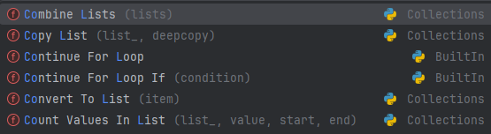

Library String

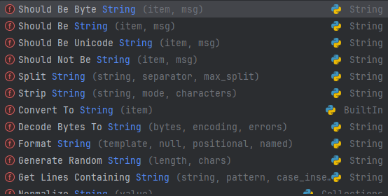

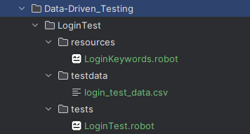

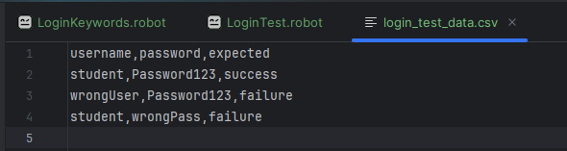

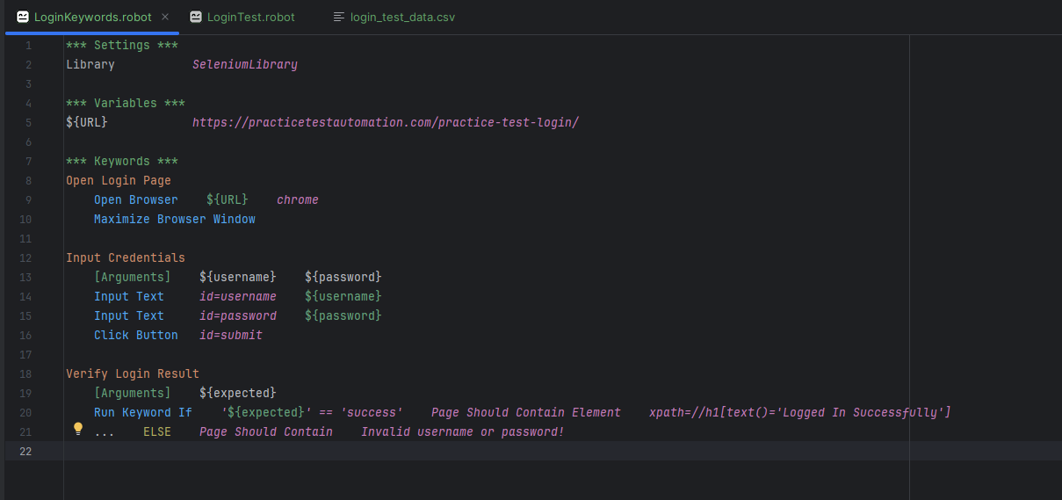

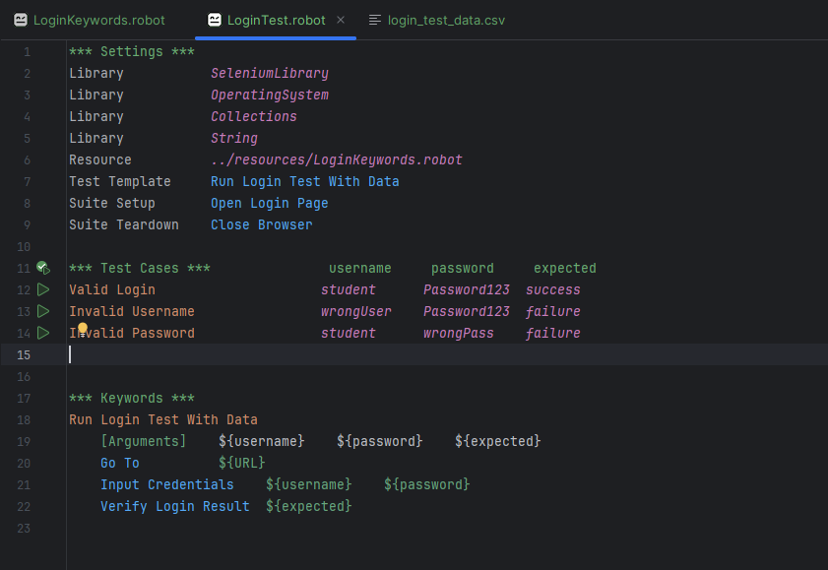

# 18 Control Statement

In Robot Framework allows repetitive execution of keywords over a list, range, enumerate using the FOR keyword.

The loop is closed with an END statement (in Robot Framework 4.0+), or uses a backslash(\) for inline loops.

Syntax

FOR ${variable} IN list_or_range

# Keywords to execute in the loop

END

# 1. For

1. For Loop

1. FOR Loop (Inline Loop)

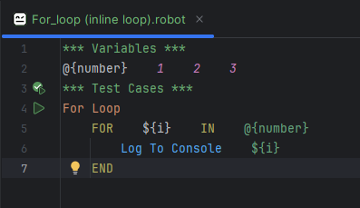

2. FOR Loop with IN RANGE

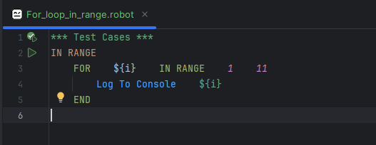 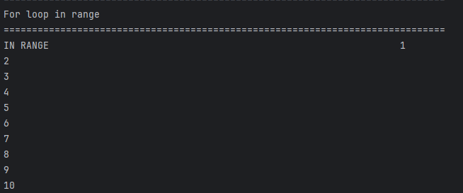

3.FOR Loop with IN ENUMERATE

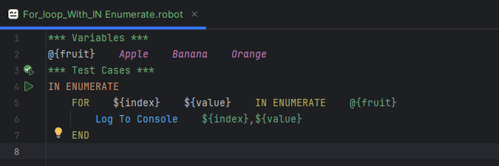

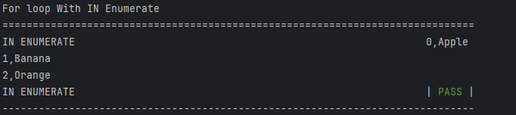

4. FOR Loop With IN ZIP (Some Error)

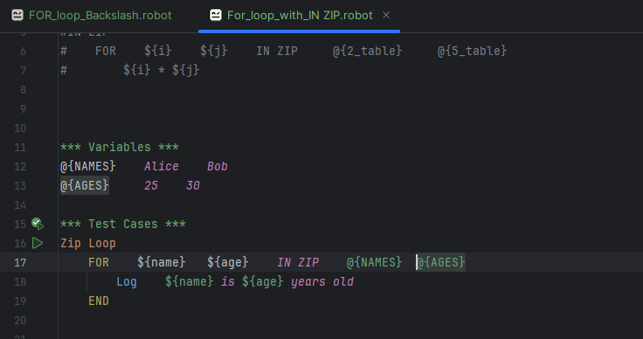

5. For Loop With BackSlash (\)

(Some Error)

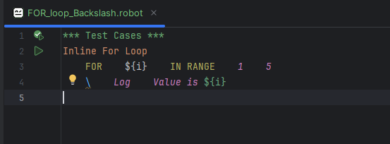

6. For Loop Inside a keyword

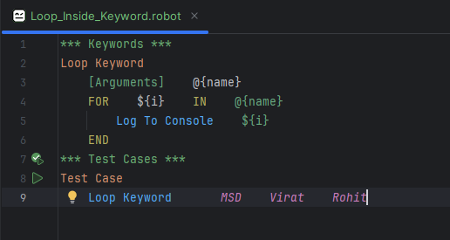

7. Nested FOR Loop

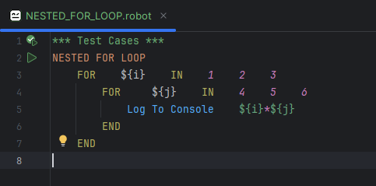

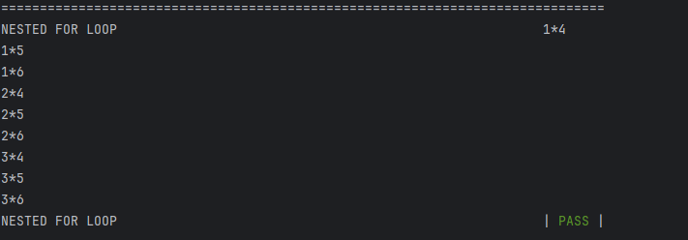

8. Loop With If Condition

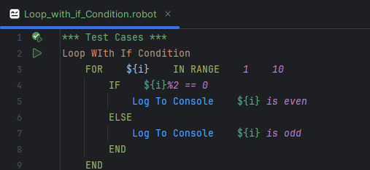

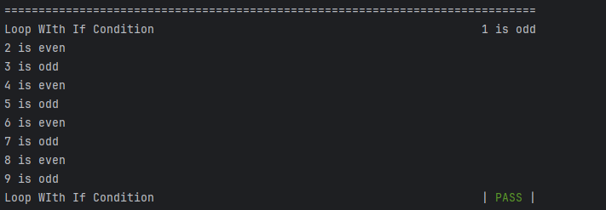

# 2. If Condition

Syntax

IF condition

Keyword execute condition

END

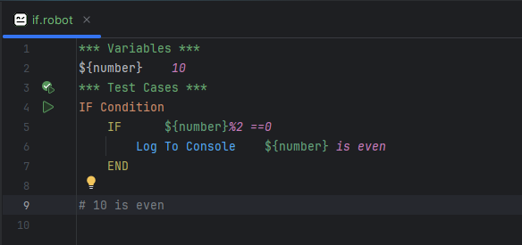

3. IF AND ELSE

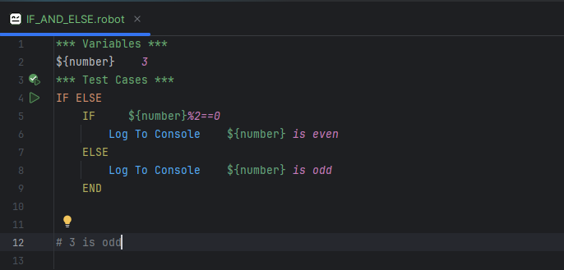

4. IF ELIF ELSE

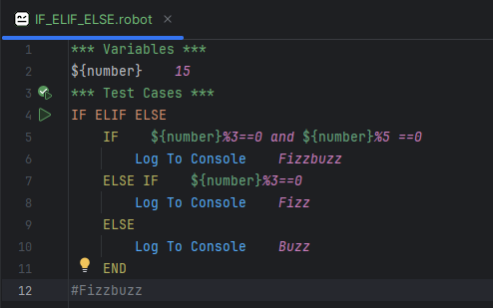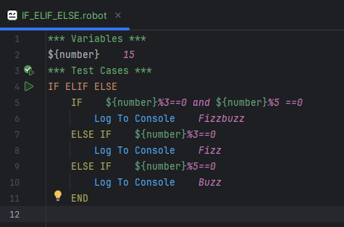

5. For IF ELSE IF ELSE

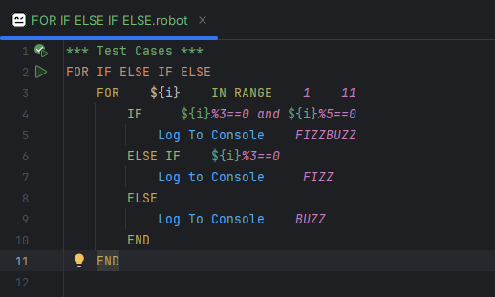

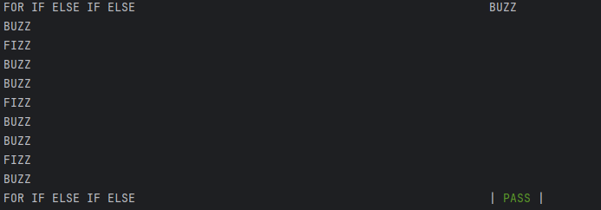

# 19 Logging

1. Log

The Log Keyword is used to log general message during test execution. You can specify a log level and the message you want to log.

Syntax

Log ${message} ${level} it is Optional

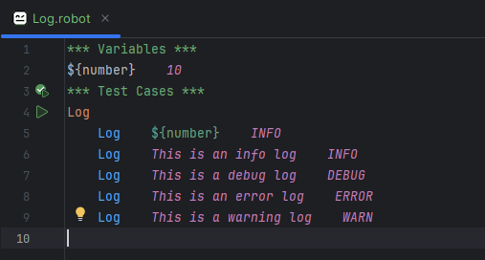

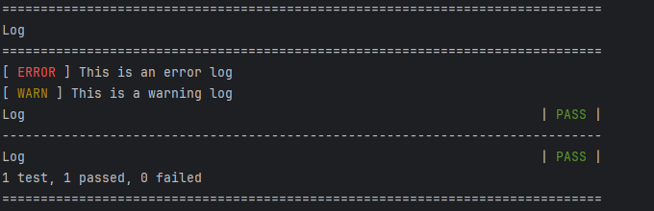

2. Log To Console

The Log To Console Keywords logs a message directly to the console,which is particulary useful when you want to print message.

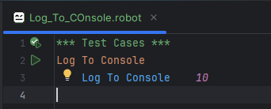

3. Set Test Status

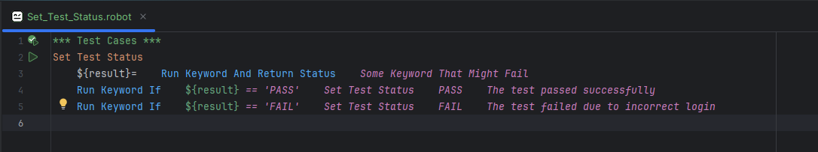

4. Log a String message

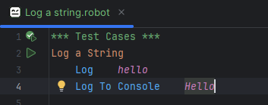

5. Log a Variable

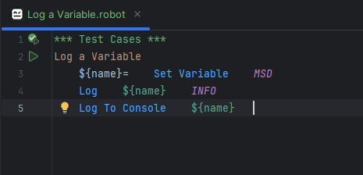

6. Log With Create list

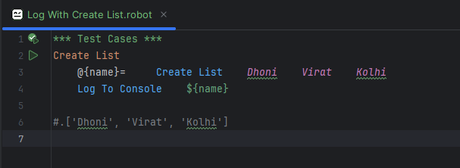

8. Log with create Dictionary

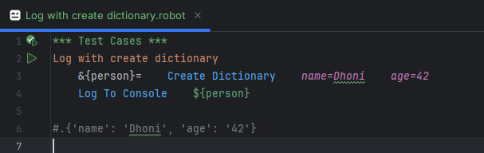

Log are store in Log html

# 19.1 String Handling

String handling in robot framework is done using build-in String library keywords,which provide powerful ways to manipulate and validate strings.

Importing

Library String

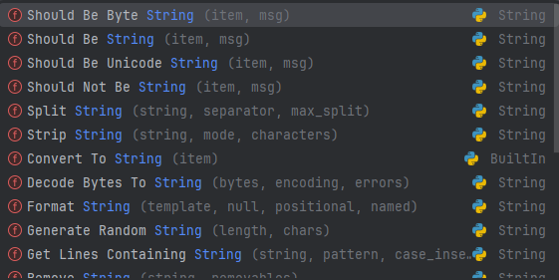

String Method

1. Convert To Lowercase

Uppercase character convert into lowercase

2. Convert To Uppercase

Lowercase character convert into uppercase

3. Get Substring

Extract the part of the string (Start index, end index)

4. Remove String

Remove a part of string

5. Count String

Counts how many times a substring appears

6. Splits String

Splits a string by a separator

7. Strip String

Removes leading/tailing whitespaces

8. Replace String

Replaces parts of the string

1. Convert To Lowercase

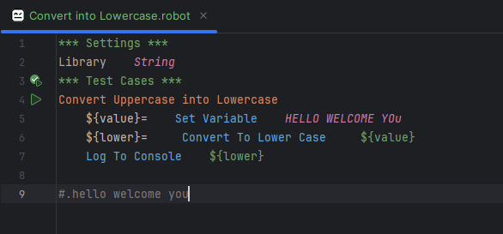

2. Convert To Uppercase

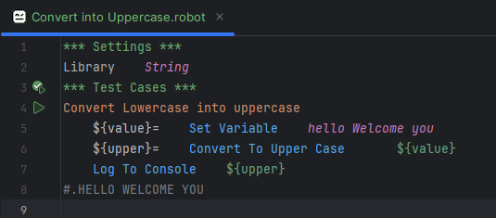

3. Get Substring

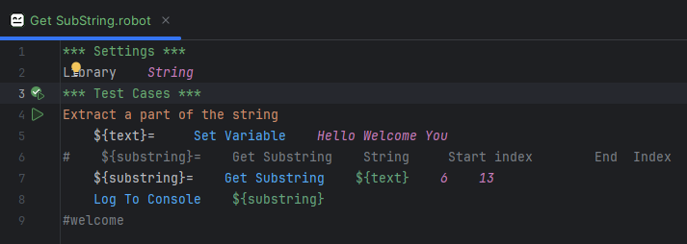

4. Remove a string

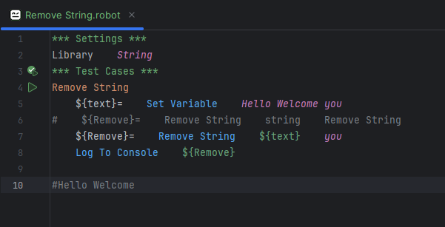

5. Count String

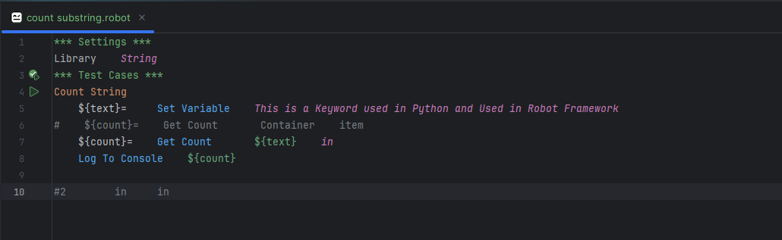

6. Split String

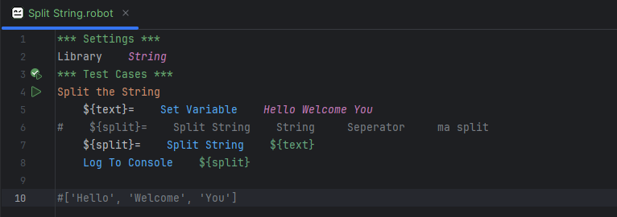

7. Strip String

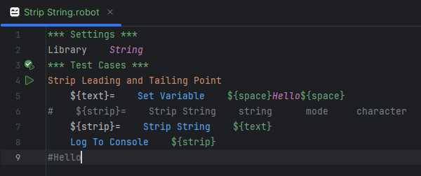

8. Replace String

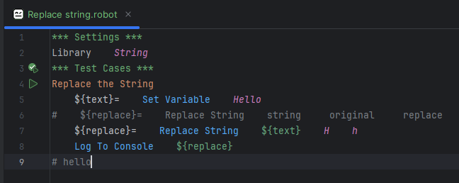

# 19.2 Data/Time

In Robot framework, you can work with date and time using the DateTime library, which provides a variety of keyword for formatting date and time

1. Importing the DateTime Library

*** Settings ***

Library DateTime

2. Get Current Date/Time

To get the current date and time, you can use the keyword Get Current Date

Format YYYY-MM-DD HH:MM:SS

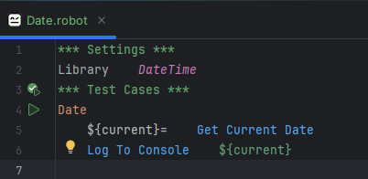

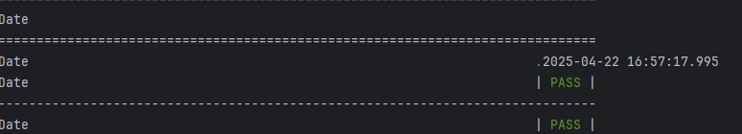

3. Get Time

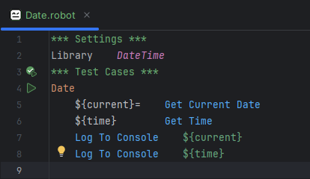 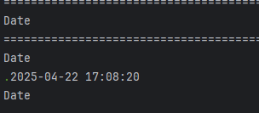

# 19.3 Sikuli

  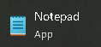 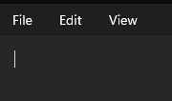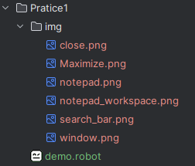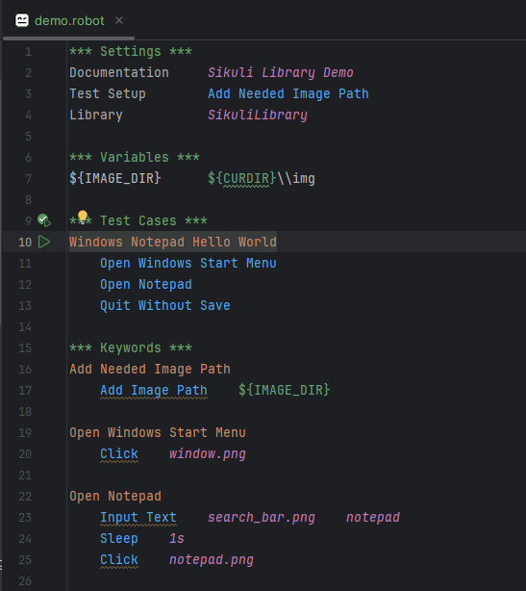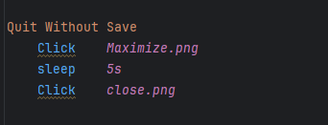

# All Keywords

Log

Should Be Equal

Run Keyword If

Set Variable

Sleep

Fail

Evaluate

Length Should Be

Click Button

Click ElementWait Until Element Is Visible

Input Text

Get Text

1.Open Browser

2. Close Browser

3. Close All Browser

4. Maximize Browser Windows

5. Go To

6. Get Location

7. Set Windows Size

8. Get Windows Size

9. Switch Browser

10. Reload Page

1. Click Element

2. Input Text

3. Select From list by Label / Value

4. Get Text

5. Element Should Be Visible/Present

6. Wait Until Element is visible

7. Execute JavaScript

8. Switch Window / Frame

Set a Default timeout

Sleep

Select From List By Label

Select From List By Value

Select Checkbox

unselect Checkbox

Select Radio Button

Alert Should Be Present

Get Alert Message

Handle Alert

Common File Operation in Robot Framework

1. Create File

2. Append To file

3. Get File

4. Get File Lines

5. File Should Exist and Folder Should Exixt

6. Remove File

7. Modifying a File (Read, Modify, Write Back)

8. Copy File, Move File

9. Create Directory, Remove Directory

FOR

END

FOR Loop with IN RANGE

IF condition

IF AND ELSE

IF ELIF ELSE

For IF ELSE IF ELSE

String Method

1. Convert To Lowercase

2. Convert To Uppercase

3. Get Substring

4. Remove String

5. Count String

6. Splits String

7. Strip String

8. Replace String

#### Option 1: Using JavaScript to Hide the Window (simulate minimize)

robot

CopyEdit

Execute JavaScript window.blur()